Custom AR Invoice

Page through VBCS

ROOT URL | VERSION | SOURCE VERSION | VBCS VERSION
 | 1.0.32 |  | 20250618-24.10.9

Author: M Rahul Vardhan
Creation Date: Sep 09, 2025
Last Updated:
Version: 1.0

Contents
About 3
Pre-requisites in Services. 4
Creation of the backends 4
Calling the service connections: 4
Customer Invoice page overview 20
Customer Invoice – VBCS Implementation 20
Steps to Add Components in VBCS 21
Sections for Headers and lines. 27
Creation of the Customer Page. 28
Steps to Add Title In the VBCS page. 28
Steps involved to add the Header details. 29
Steps included for the development of Header related fields. 29
Steps included for the development of Customer and Payment Terms. 38
Steps involved for the development of the distributions fields: 43
Steps involved to develop the lines field: 45
Calling the post method to create the customer. 50
• Then we will call the Rest connection in the Response. 52
• Calling the notification in the page like it created or not created. 52
The Overview of the Page. 53

About
The Customer AR Invoice page captures customer details at the header level, along with the associated lines and distributions. The customer is created through service connections.

Front-End (User Interaction):
- Built in VBCS (Visual Builder) — shows Customer related fields.
- Example: Headers , lines and the distributions.

Back-End (Logic & Integration):
- Integration Layer using Oracle Integration Cloud (OIC):
  - Triggers from button clicks like save.
  - Calls REST APIs
  - Handles business logic for AR invoice creation in Fusion from VBCS page.

Data Layer:
- Bo (Business Objects).

Pre-requisites in Services.

Creation of the backends
- Giving the Osami crediantials for the backend where the service connections calling it from the backend.
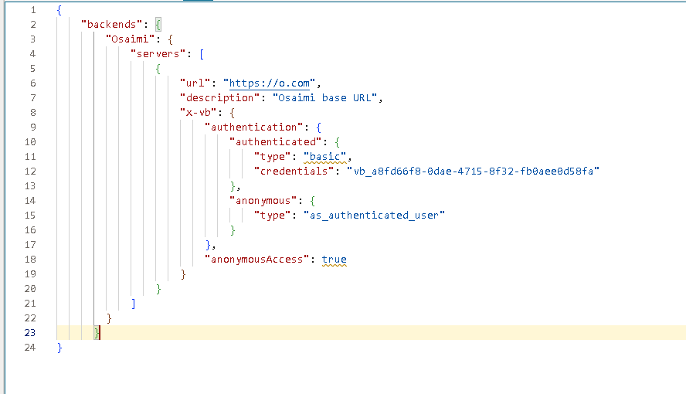

Calling the service connections:
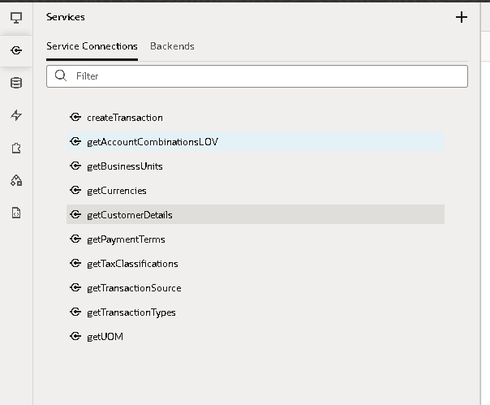
- List of the service connections are used based the backend of osami Connections.
- CreateTransaction Service connection:
- Overview: The overview of the page.
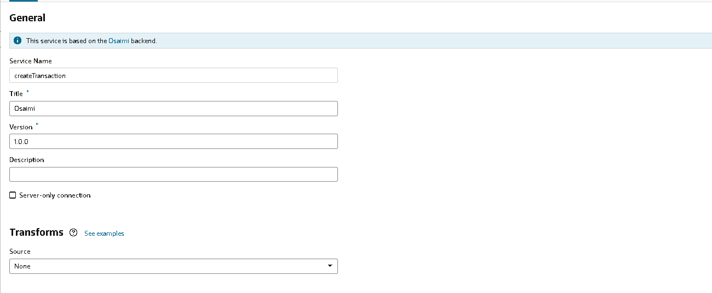
- End point (Request & Responses)
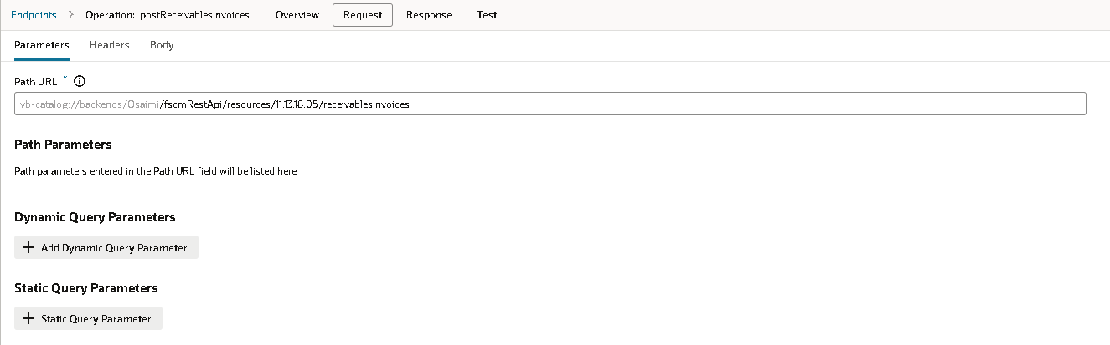 | 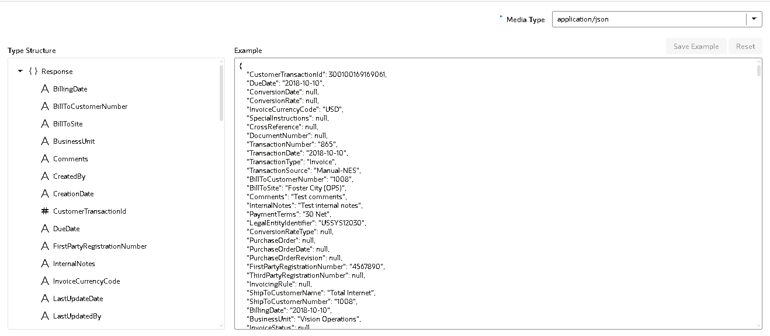
Test:
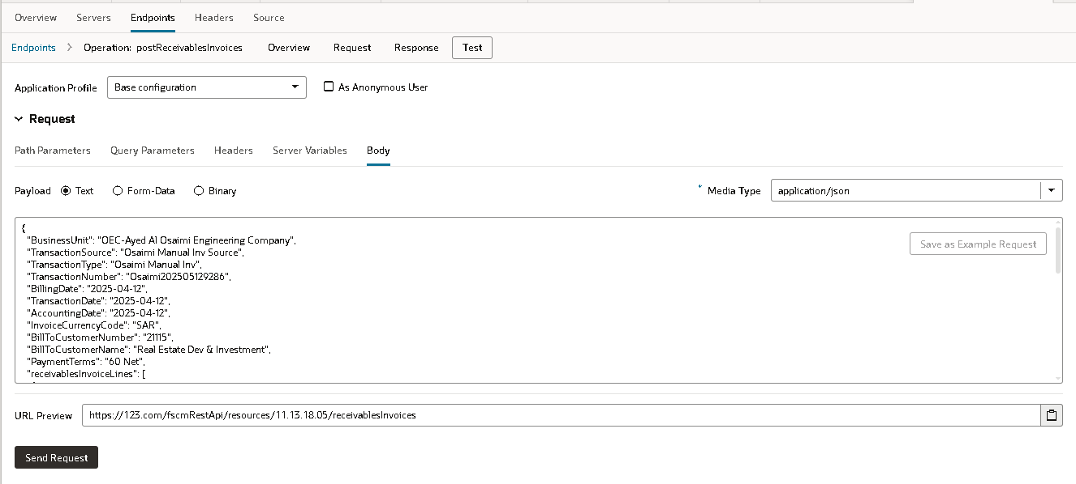
- getAccountCombinationsLOV
- Overview
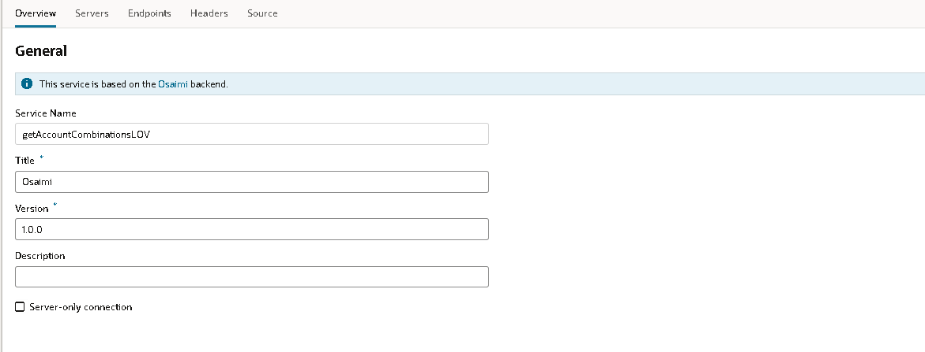
- Endpoint
Overview:
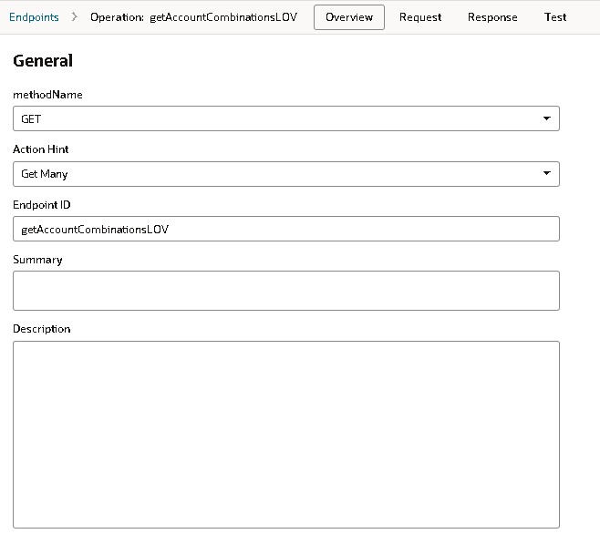
Request:
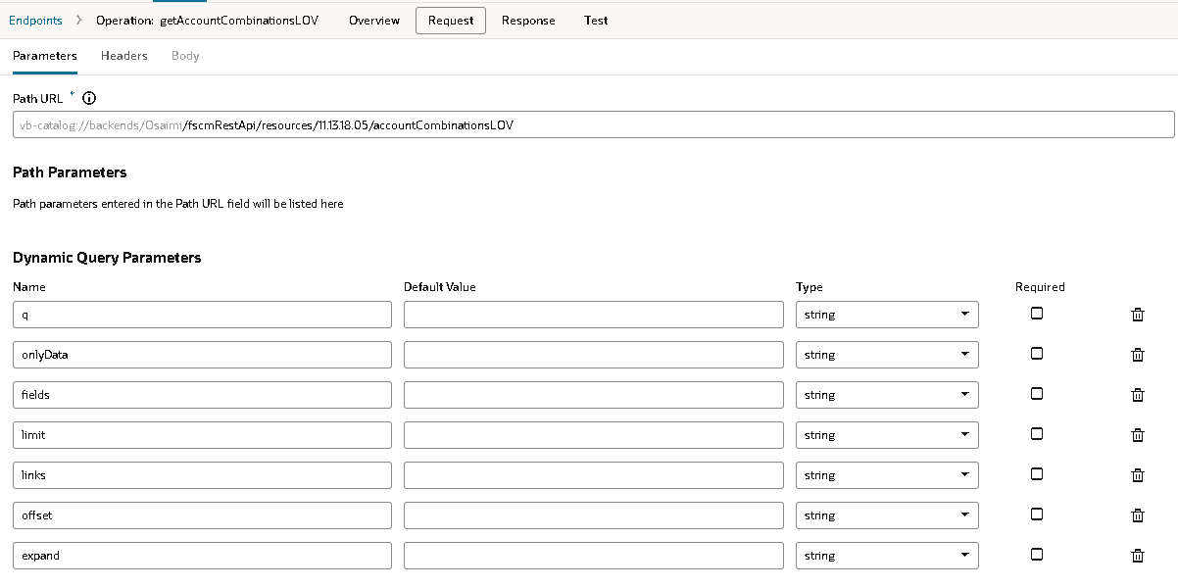
Response:
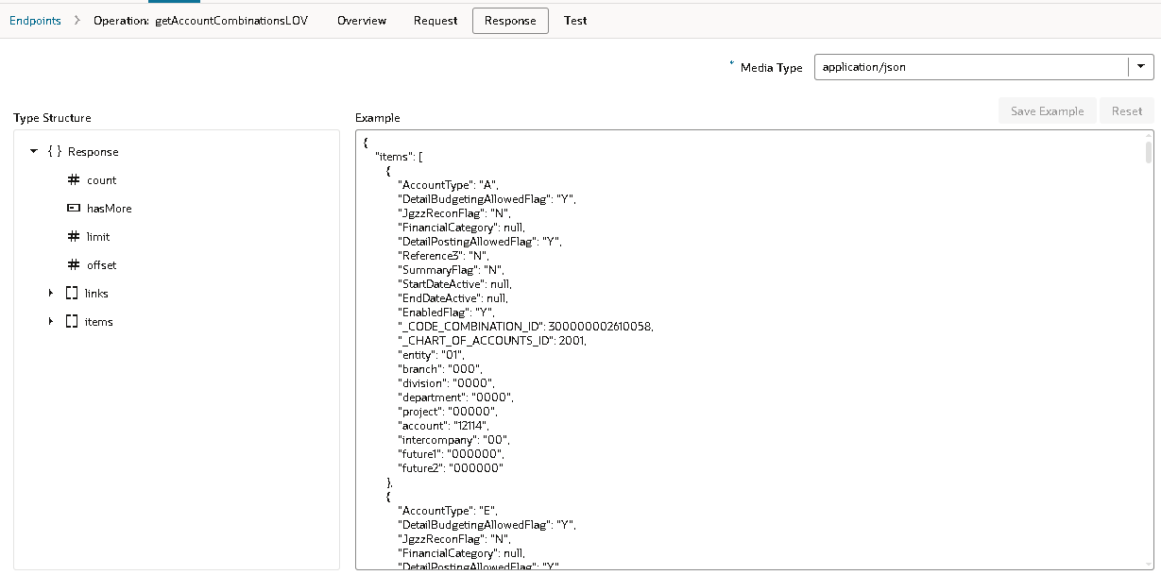
- getBusinessUnits
- Overview:
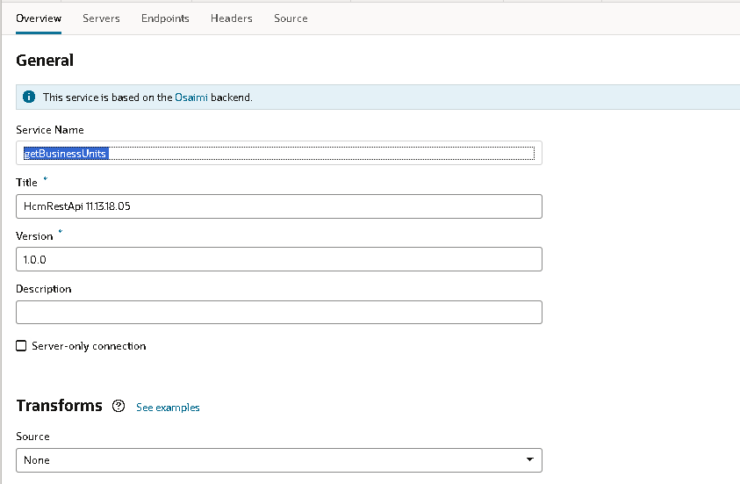
- Endpoint:
Overview:
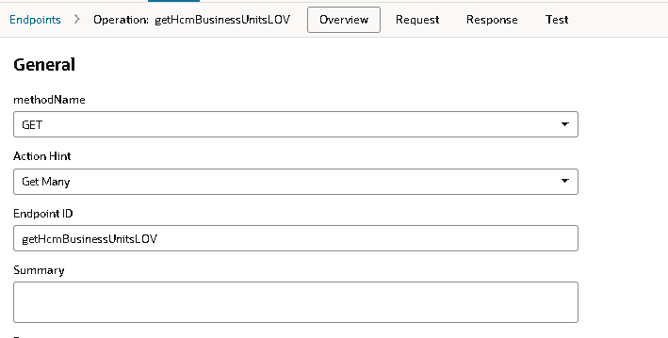
Request:
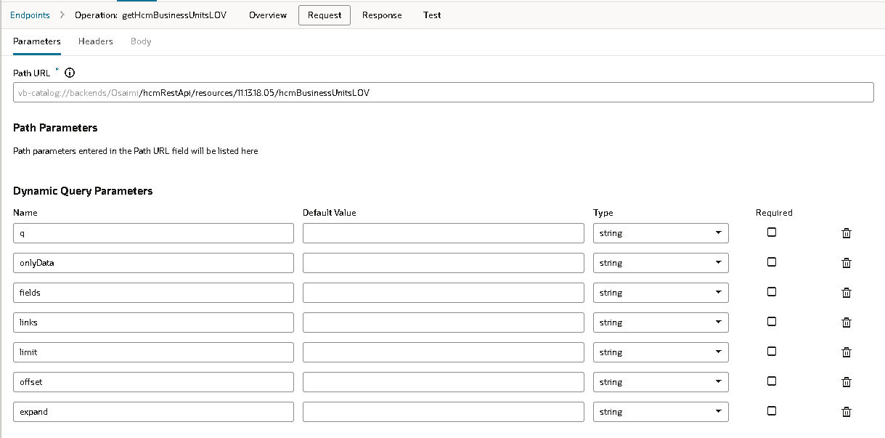
Response:
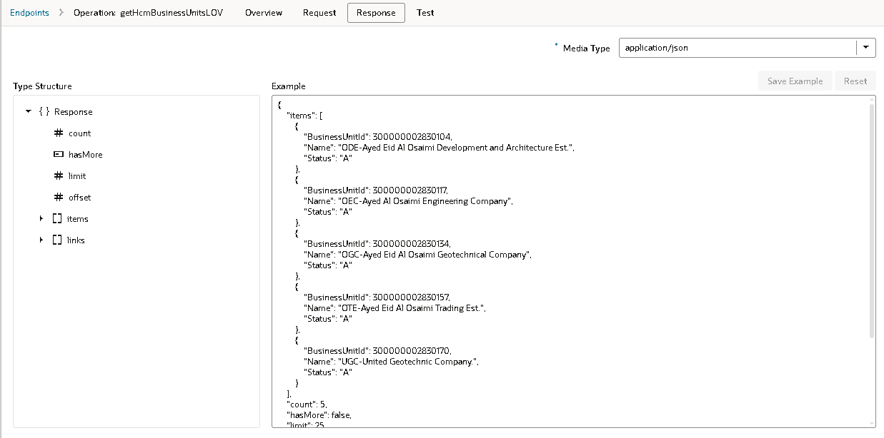
- getCurrencies
- Overview
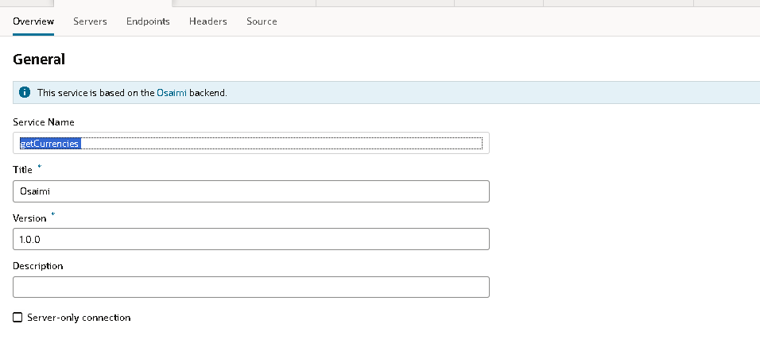
- Endpoints
Overview
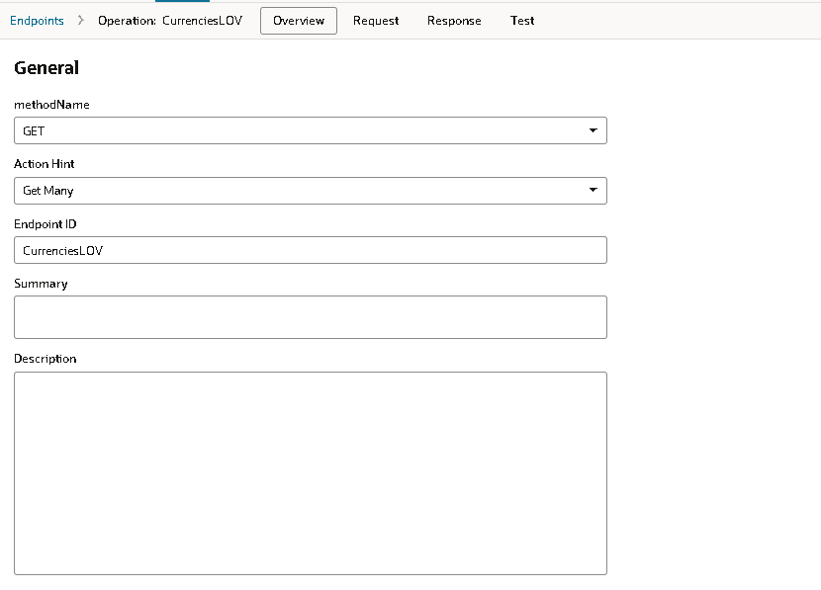
Request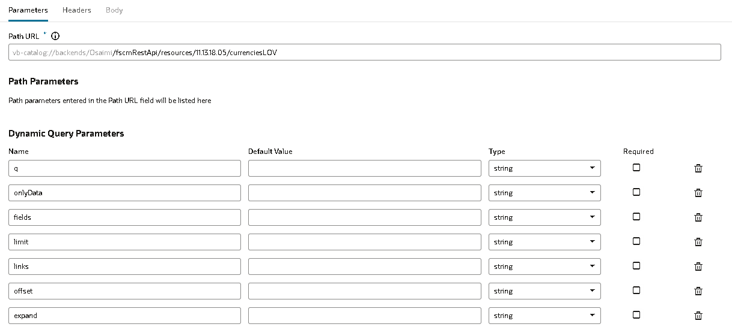
Response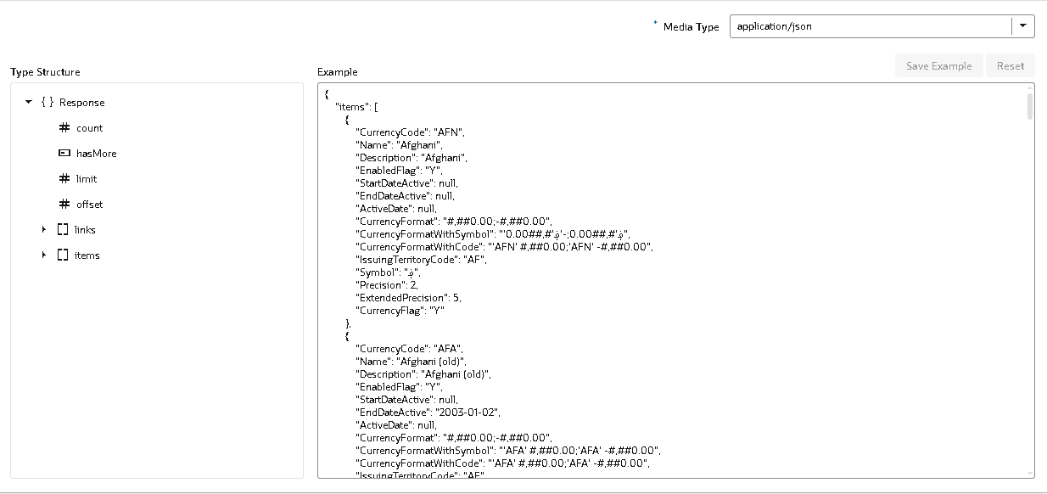
- getCustomerDetails
- Overview
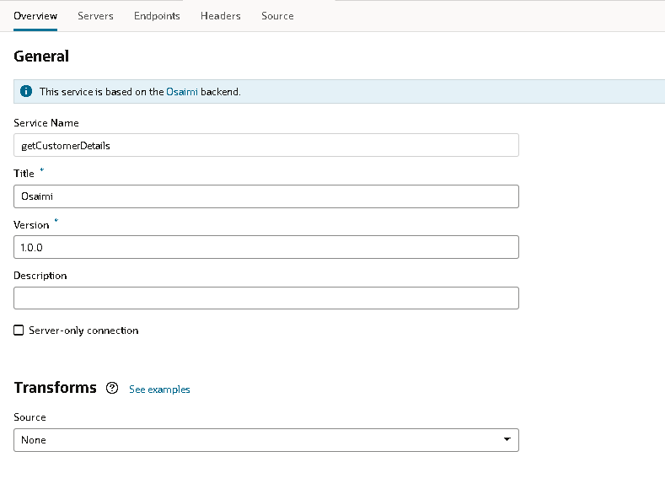
- Endpoint
Overview: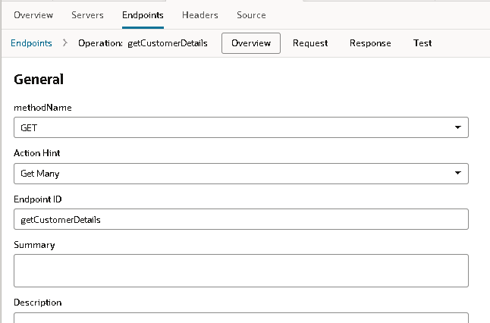
Request: 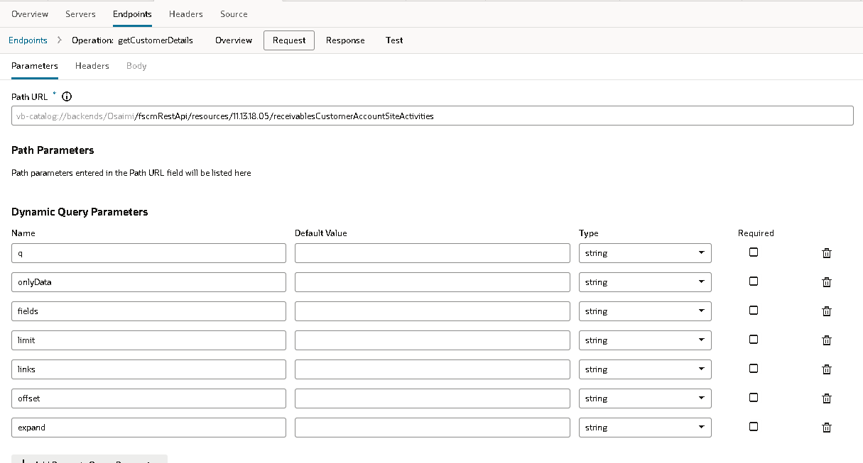
Response: 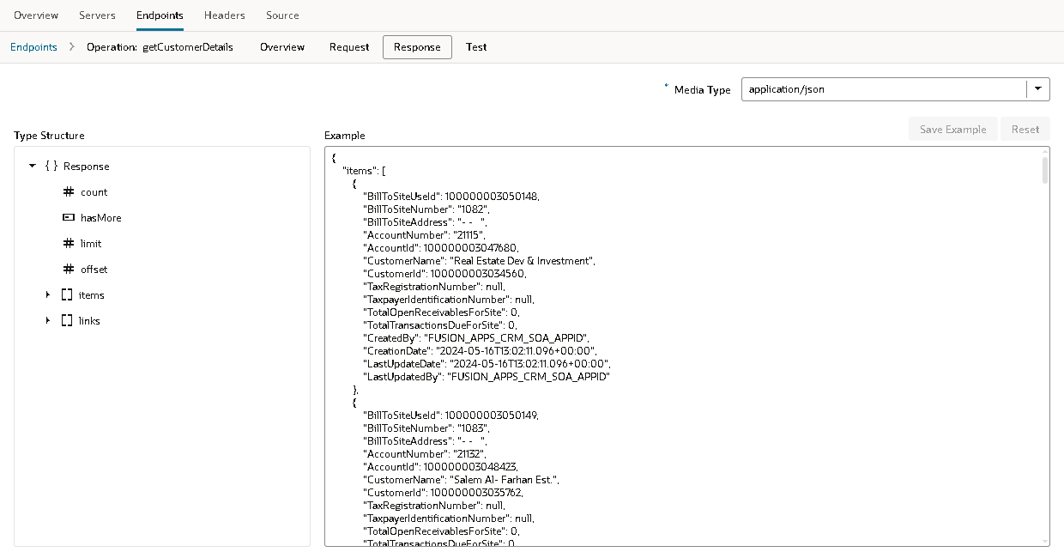

- getPaymentTerms
- overview
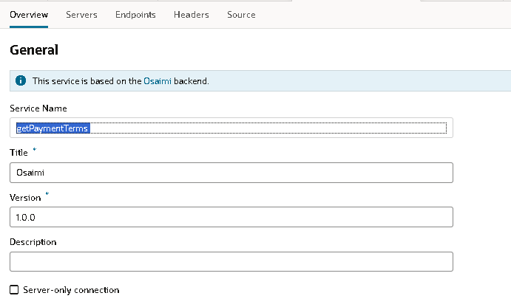
- End points
Overview
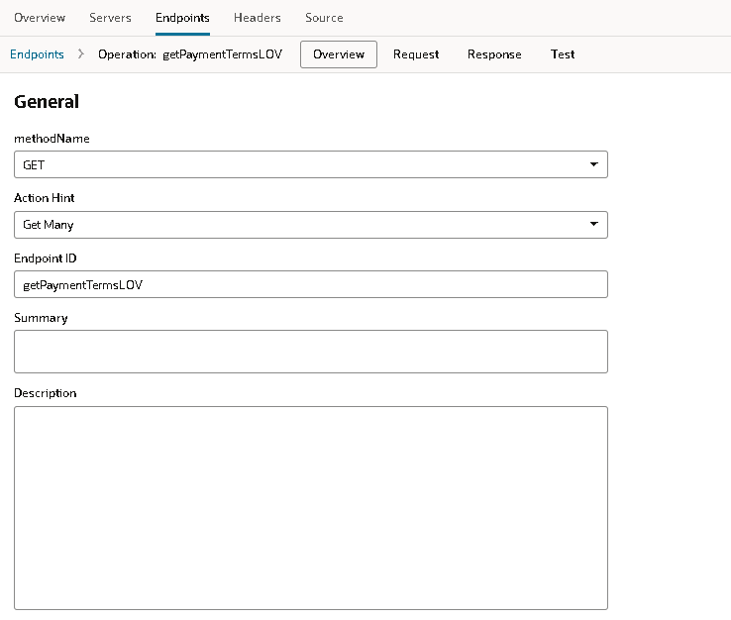
Request 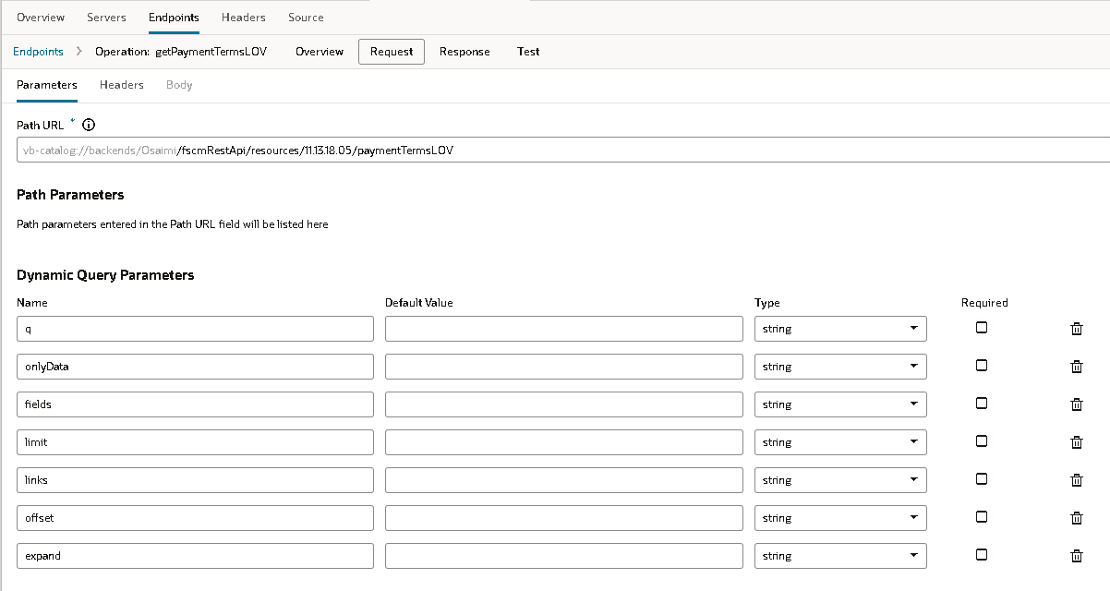
Response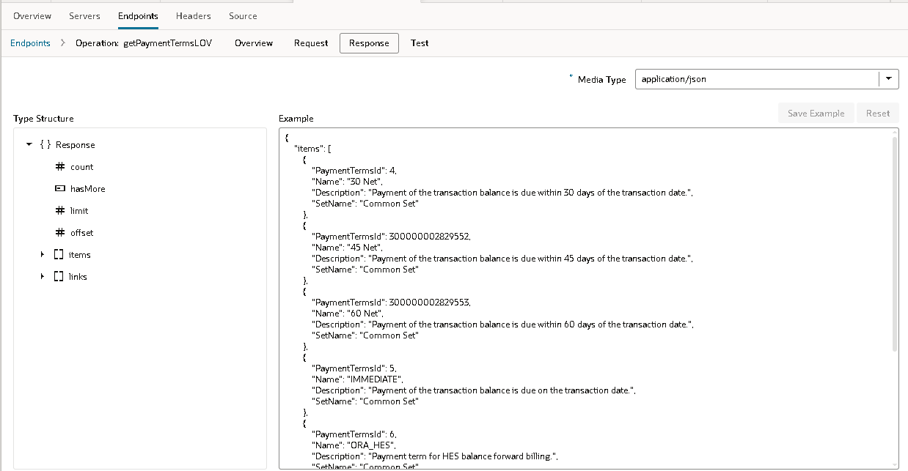
- getTaxClassifications
- Overview
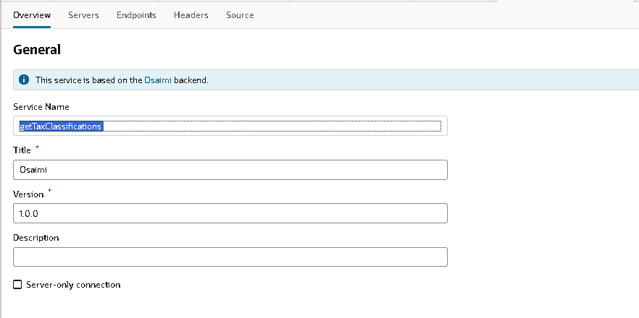
- Endpoints
Overview: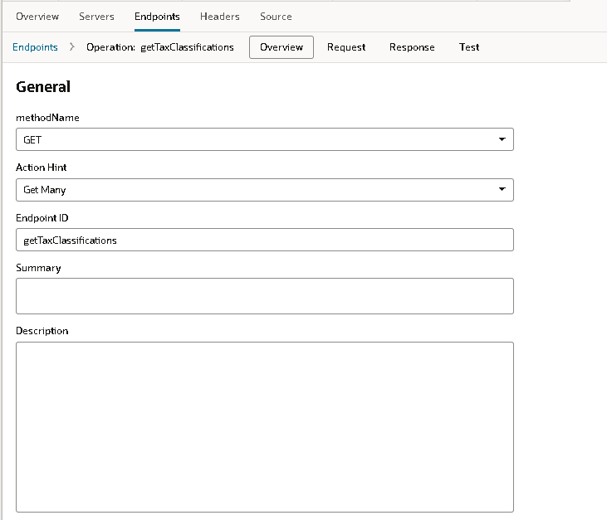
Request: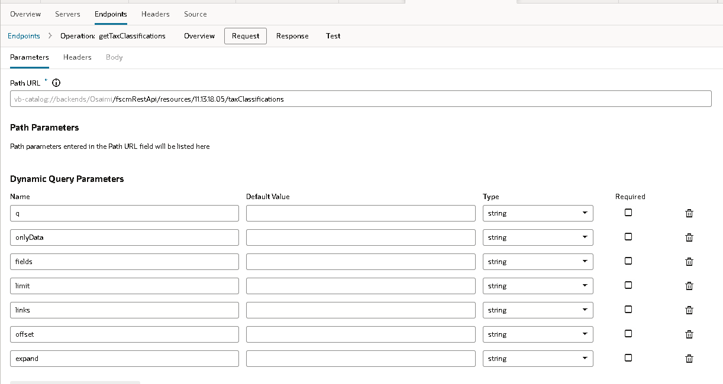
Response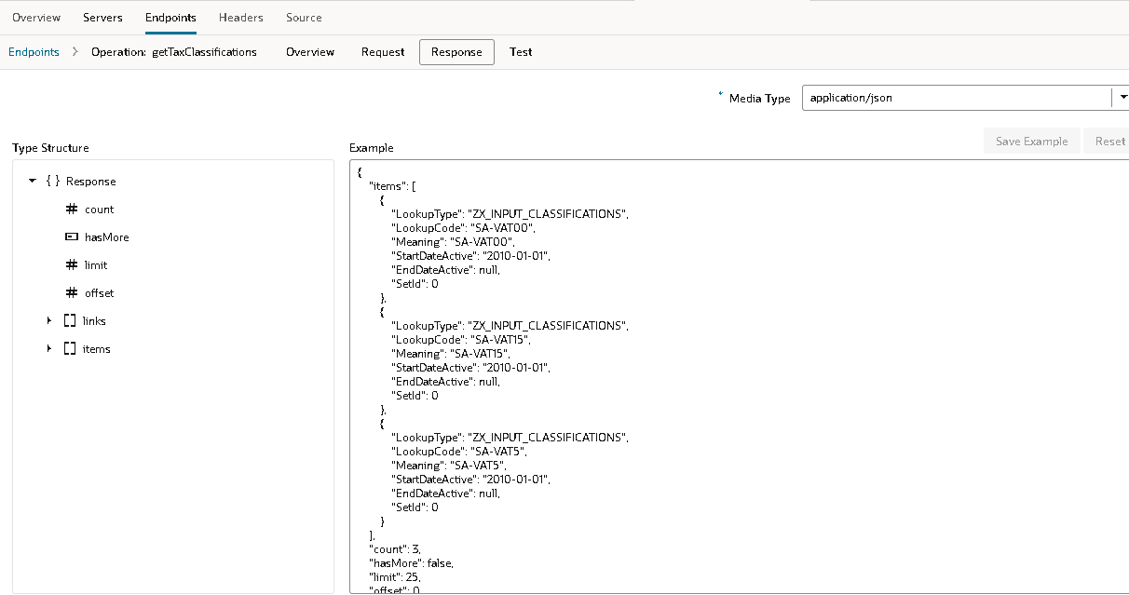
8. getTransactionSource
- Overview
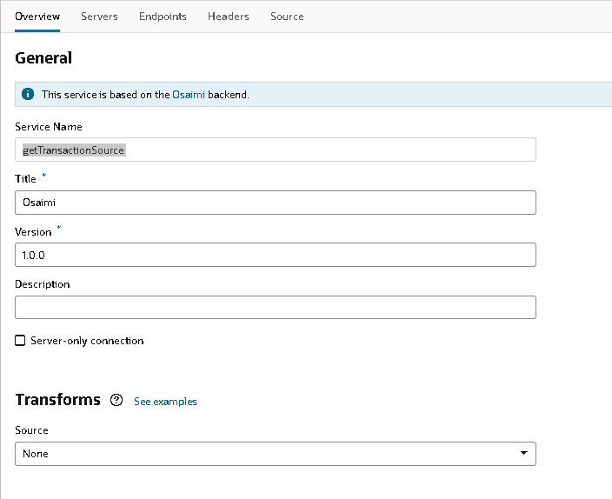
- End points
Overview: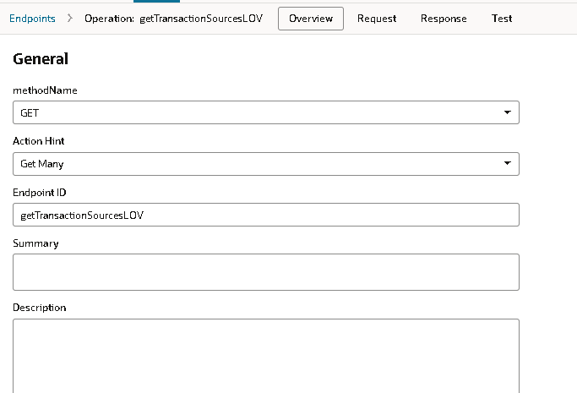
Request: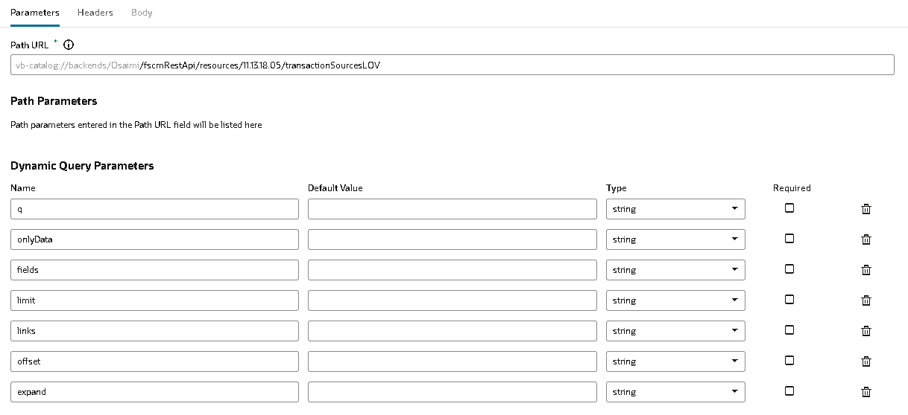
Response: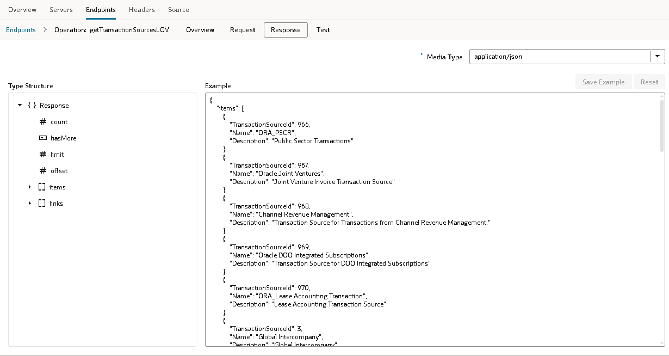

9. getTransactionTypes
- Overview:
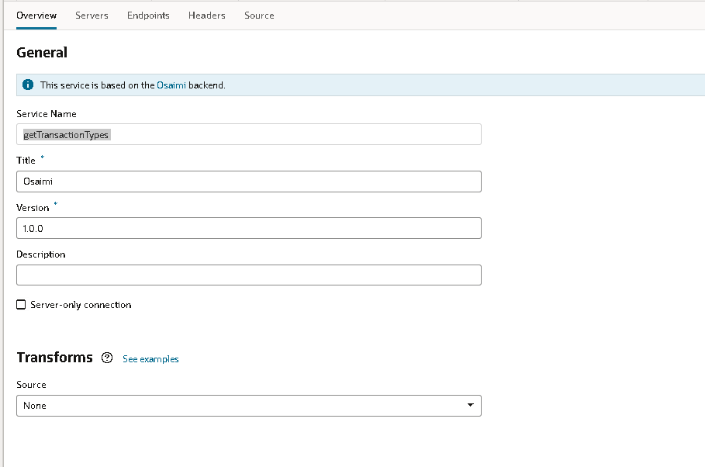
- End point
Overview:
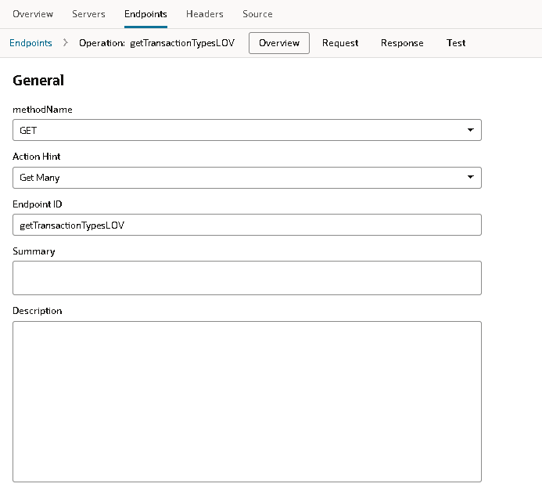
Request:
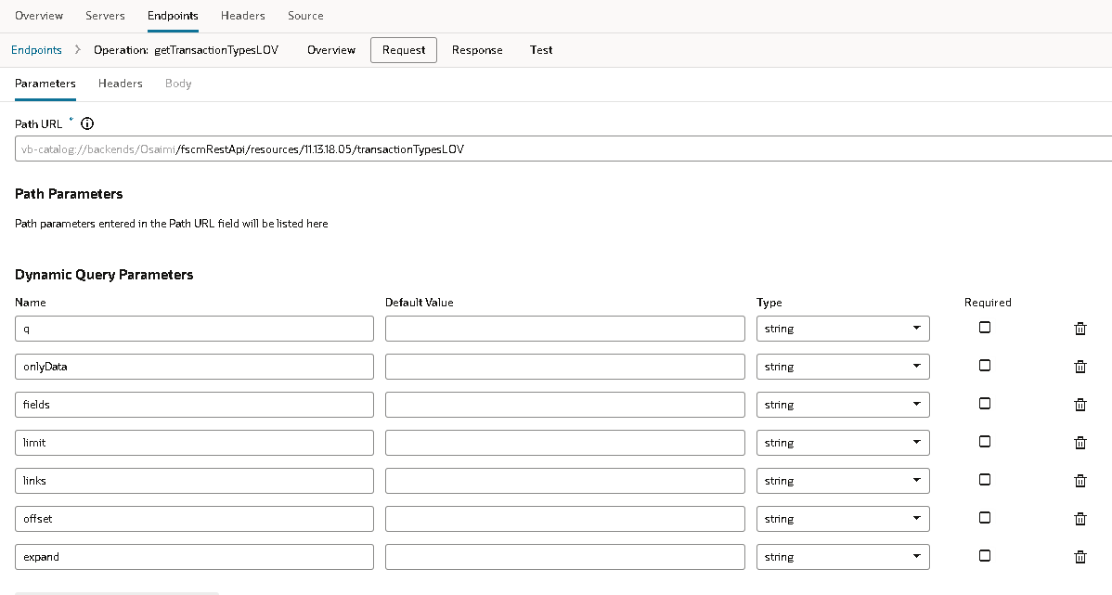
Response
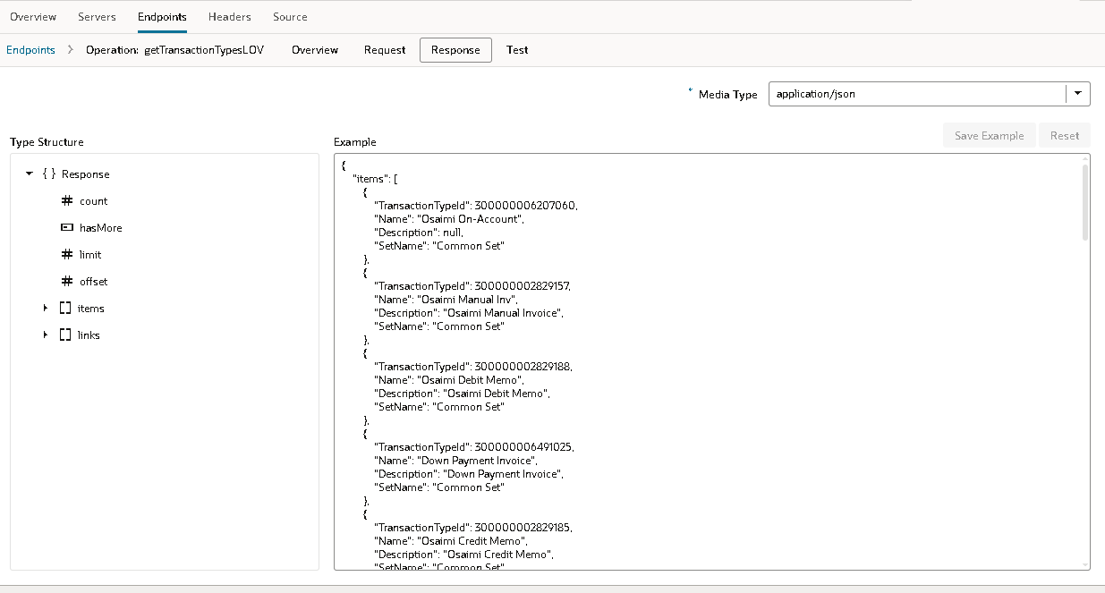

10. getUOM
- Overview:
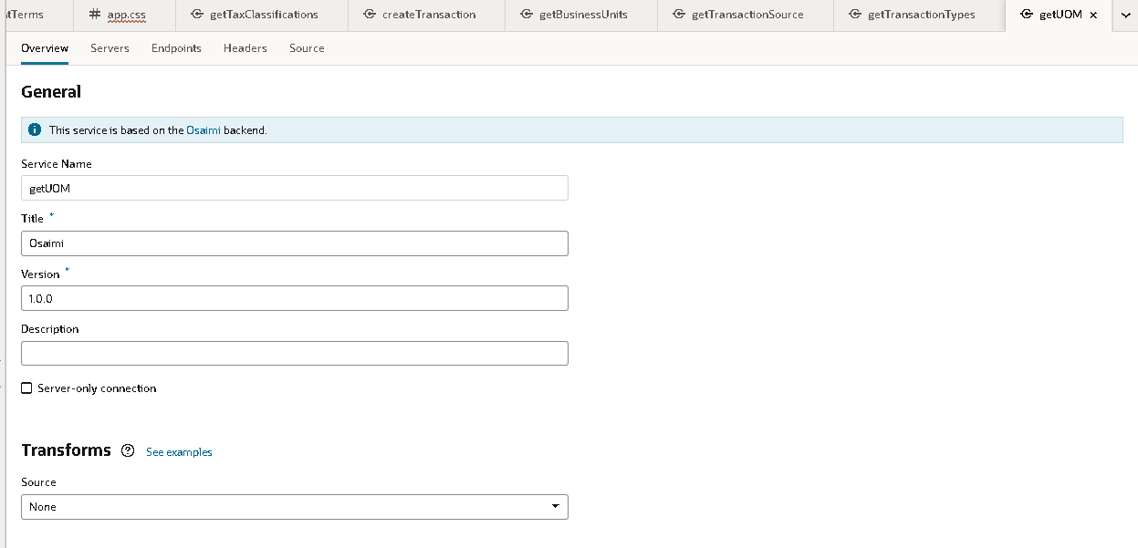
- End point:
OverView
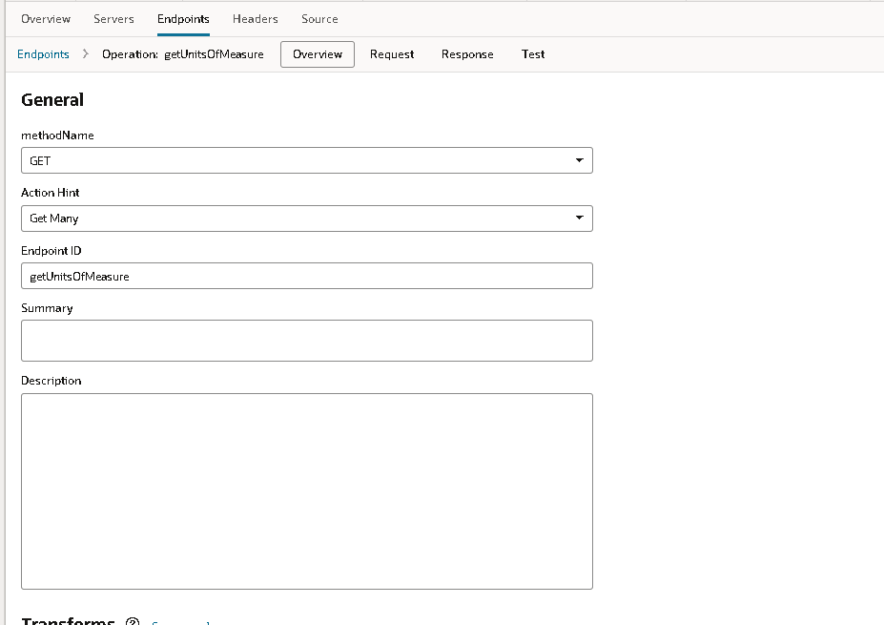
Request:
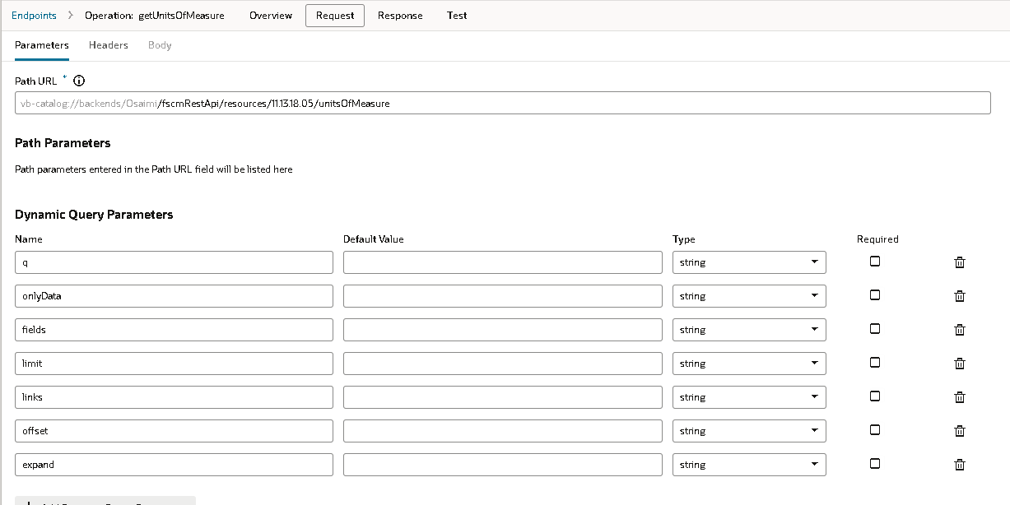
Response:
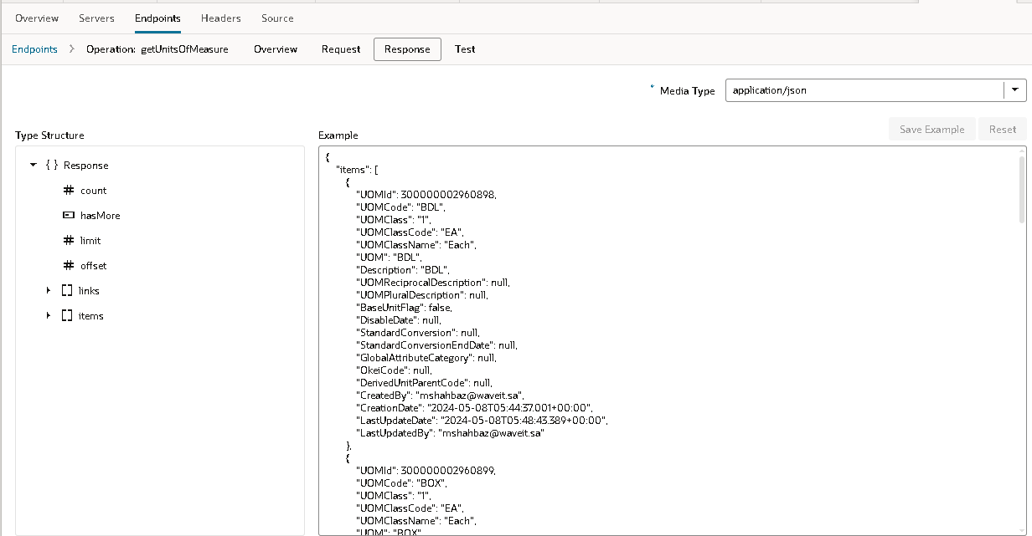

Customer Invoice page overview
- Page overview
The customer Invoice page represent the overview of the some of the fields in the customer which includes the mandatory fields of both headers and lines.

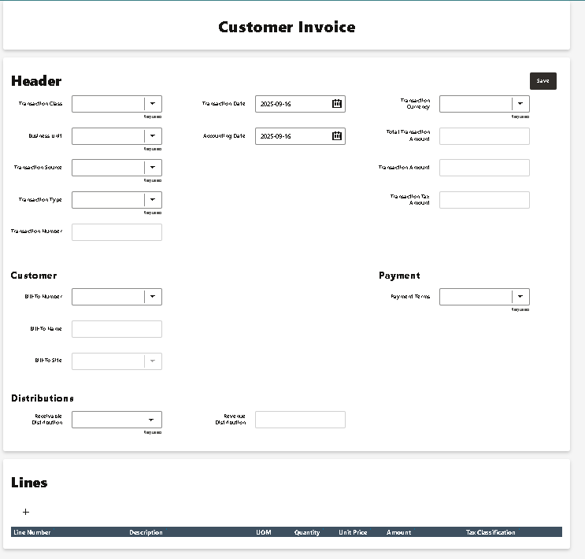

Customer Invoice – VBCS Implementation
Components Used
- Heading – Page Title
- Input Fields , Combo Box– The fields to store the data.
- Buttons – Save and running the programs.

Steps to Add Components in VBCS

1. Add the Page Heading
- Open your Custom page in VBCS Designer.
- From the Components Palette, drag Heading onto the page.
- Set the Heading text in the Properties panel to Customer Invoice.
- Optionally, adjust style (size, alignment, color).

2. Add the Input fields
- From the Components Palette, drag the Input Text and Combo box → (below the Heading).
- Optionally, adjust style (size, alignment, color).
- Attaching the service connections and the action for it.

3. Add the Buttons.
- From the Components Palette, drag a Navigation or Button Bar component (depending on design preference).
- Add buttons for key tasks such as:
  - Save
  - Icons
- Bind each button’s Action to the respective navigation flow or REST call (Fusion as needed) through service connections.
- Place the task bar either:
  - Placing the save button
  - And the ‘+’ icon for the lines and also delete icon.

4. Calling the Action chain for the page.
- Page VB enters event on the chain.
- It runs on the Entire Page
- In the actions called the Run in Parallel logic .
- In every block the service connections get is used and stored in the variable.
- 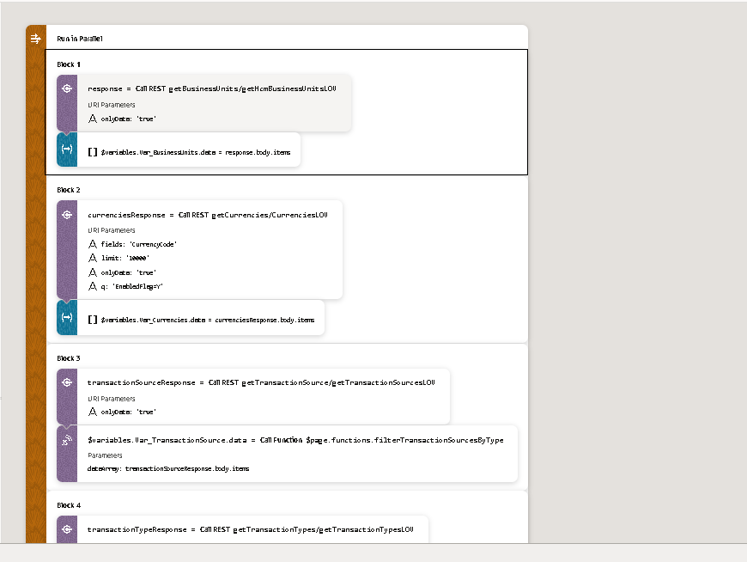
Block 1: called the Business unit rest api and stored in the Var_BusinessUnits.data array.
Block 2: Called the currencies get api and called the rest api of the currencies.
Assigned in the Variables.var_currencies.data array.
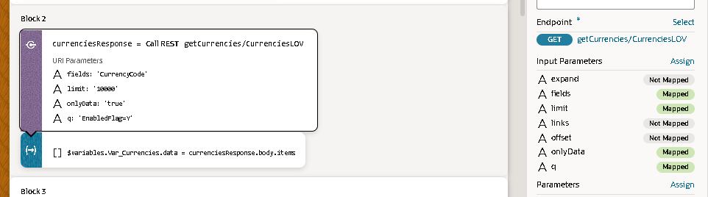
Block 3: Calling the getTransactionSource data in service connection.
Calling the function inside the block 3
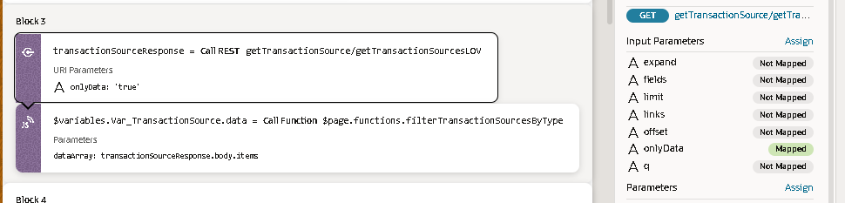
The function called is filterTransactionSourcesByType
filterTransactionSourcesByType(dataArray) {
const keywords = ["inv", "credit memo", "debit memo"];
return dataArray.filter(item => {
const name = (item.Name || "").toLowerCase();
return keywords.some(keyword => name.includes(keyword));
});
}

Giving the parameter as the {{ transactionSourceResponse.body.items }}.
It filters the list of transaction sources and returns only those whose Name contains "inv", "credit memo", or "debit memo".
Block 4: Calling the get transaction types details.
Storing the data in the variables Var_transaction type.
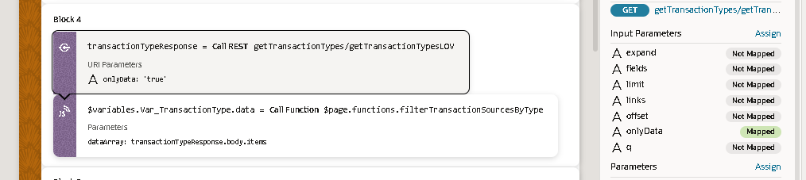
Calling the javascript function for the types is same function.
filterTransactionSourcesByType(dataArray) {
const keywords = ["inv", "credit memo", "debit memo"];
return dataArray.filter(item => {
const name = (item.Name || "").toLowerCase();
return keywords.some(keyword => name.includes(keyword));
});}
It filters the list of transaction types and returns only those whose Name contains "inv", "credit memo", or "debit memo".
Block 5: Calling the getAccountCombination service connections.
Calling the rest api assigning the values in the to variables as shown below.
const items = accountCombinationResponse.body.items || [];
$variables.Var_ReceivableDistributionAccounts.data = items;
$variables.Var_RevenueDistributionAccounts.data = items;

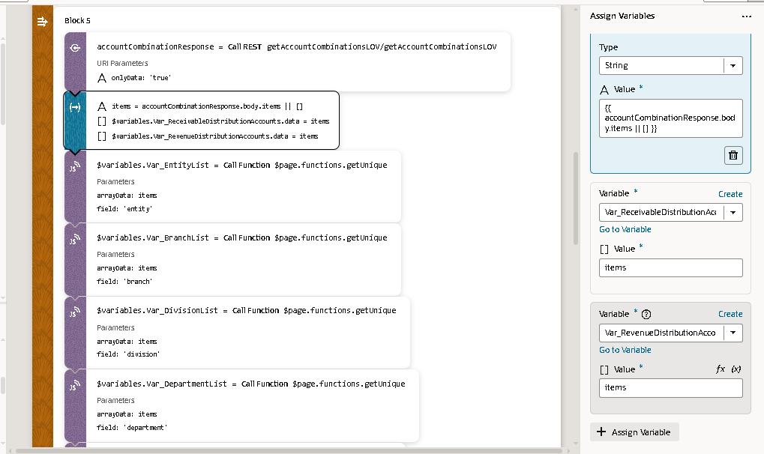
Calling the json function getUnique value in the passing the parameters as items
getUnique(arrayData, field) {
if (!Array.isArray(arrayData) || typeof field !== 'string') return [];

const seen = new Set();
const result = [];

arrayData.forEach(item => {
const value = item[field];
if (value !== undefined && !seen.has(value)) {
seen.add(value);
result.push({ [field]: value });
// key is dynamically set to field name
}
});

return result;
}
It extracts unique values of a given field from an array of objects and returns them asan array of objects like removing duplicates.
Calling the same function for more times and giving the value as the all the fields
By changing into the field name to get all unique values.
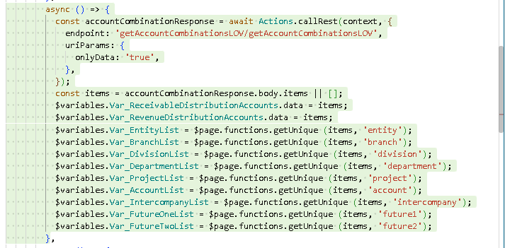
Block 6 : calling the getpaymentterms in the service connection by giving the parameters.
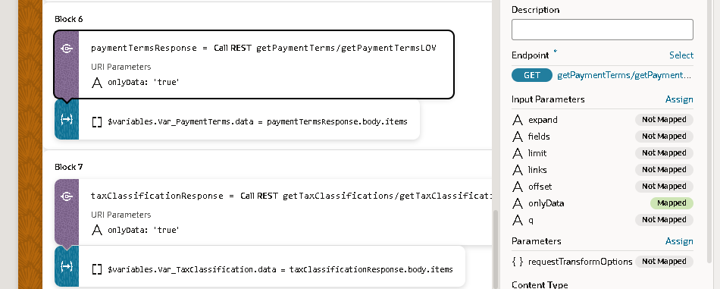
Assigining the variable Var_PaymentTerms.data the response will be stored.
Block 7:calling the gettaxclassification through the service connections.
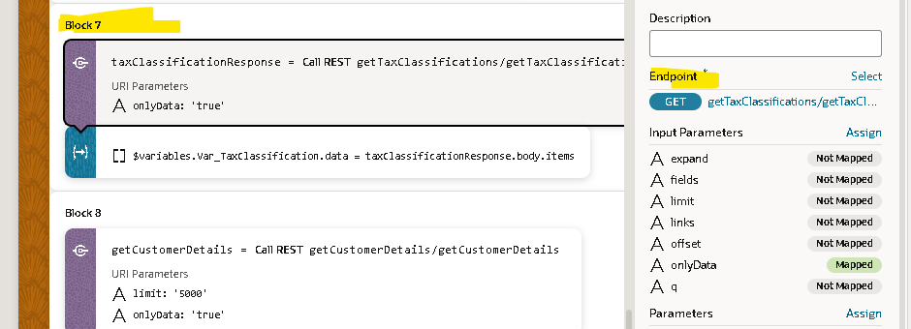
In the variable Var_TaxClassification.data the data will be stored .
Block 8: Calling the getCustomerDetails by the service connection.
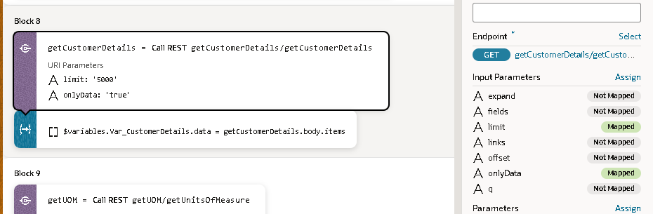
Then the variable is assigned Var_CustomerDetails.data to collect the response.
Block 9: Calling the getUOM by the service connections.
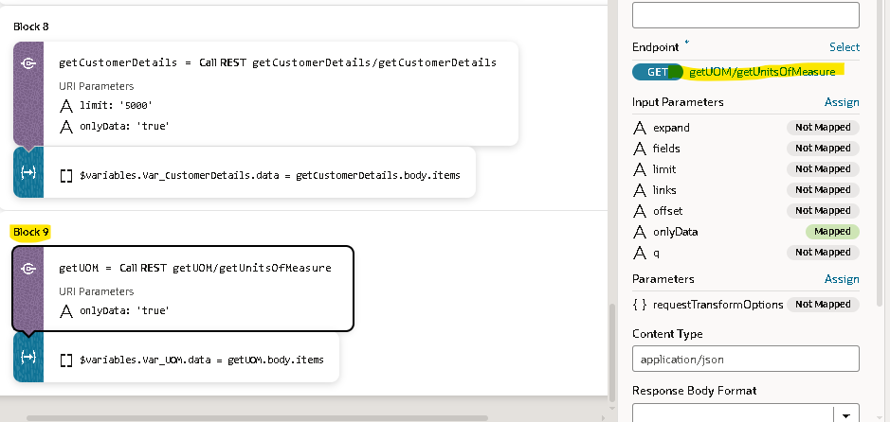
The response getting from the service connections then stored in the Var_UOM.data.

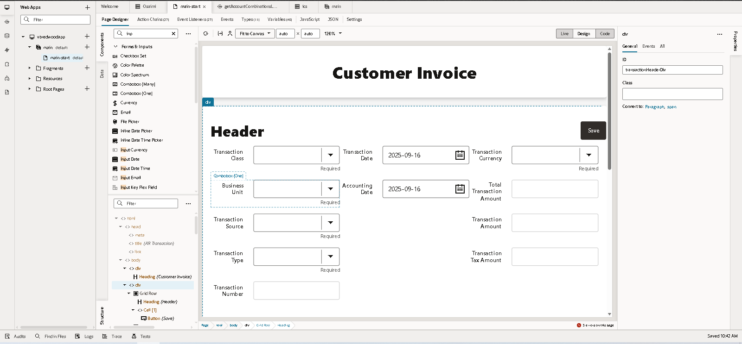

Sections for Headers and lines.
Created the different division id for it for the appearance of the lines and headers.
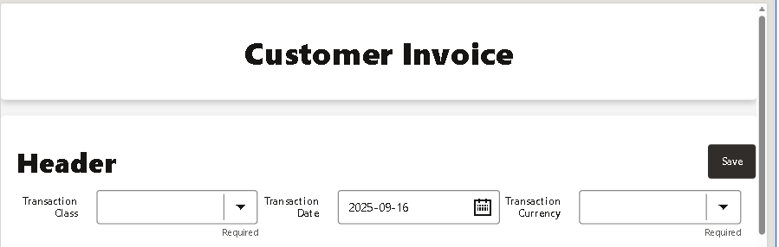
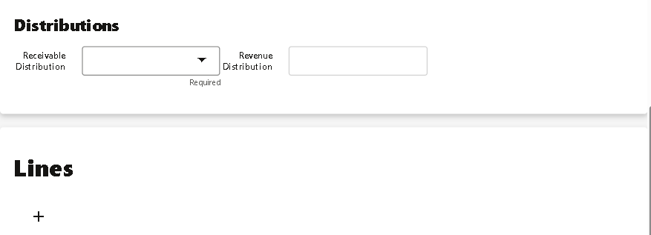
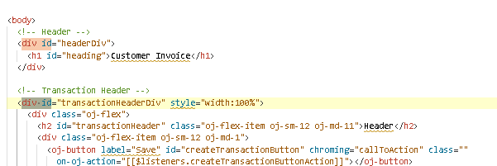

Creation of the Customer Page.

Steps to Add Title In the VBCS page.
- Added the header Div Id for the title .
- The heading will be draged in the Customer Invoice (Text) .
- Ended the Division and the appearance as below.
In this buttons we have given a functionality which will directly navigate to that related Page

Steps involved to add the Header details.
- Created another div with id for the header calling the fields or components in this div.
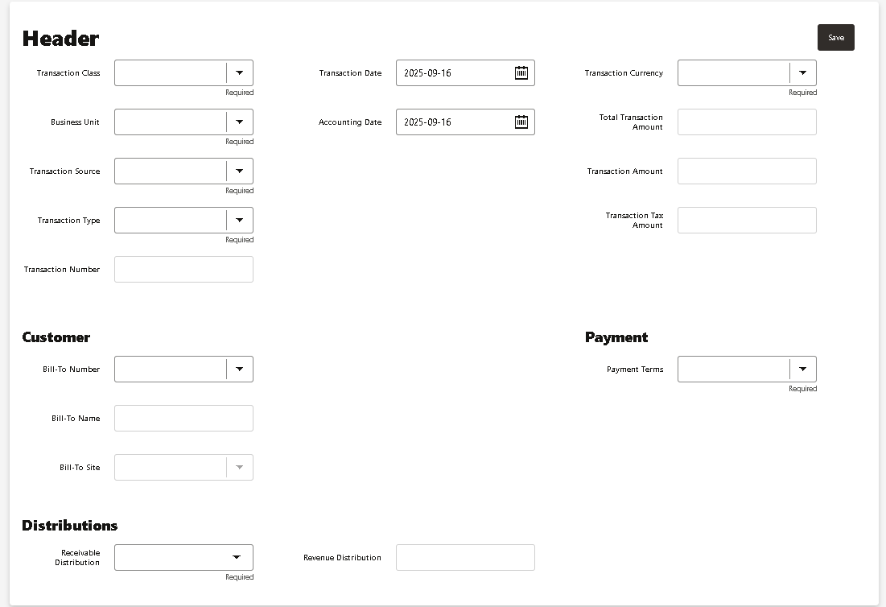
- Here we have different information like related to Header,Customer and distribution in the one div.

Steps included for the development of Header related fields.
- Transaction Class
- It’s a combox Field given label hint as a Transaction Class.
- In the data added the subelements like (Invoice,Debit Memo and Credit Memo).
- Added the action Chain in the event assigining the Trasaction class (variable) to store the data.
- Marked it as required field.
ACTION CHAIN.
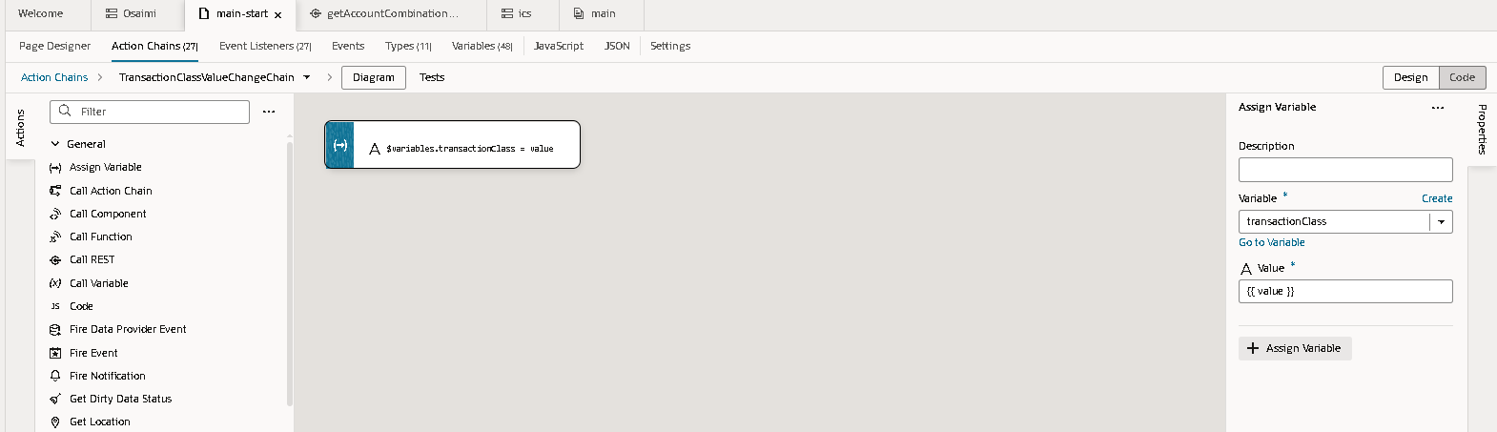
- Business Unit
- Dragged the combox value from the components and label it as Business Unit.
- Enabled it as the Required.
- Called the Options [[ $variables.Var_BusinessUnits]].
- Added the action chain in the Event storing the variable
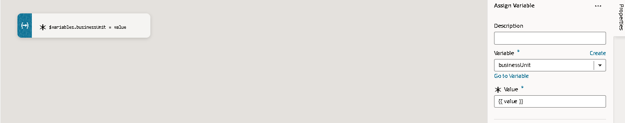
  - Var_BusinessUnits then the ITEM TYPE we will select as the getHcmBusinessUnitLov Type.
  - getHcmBusinessUnitLov is calling from the end point service connection of the getBusinessUnits.
Service Connections: getBusinessUnits
Type: getHcmBusinessUnitLov
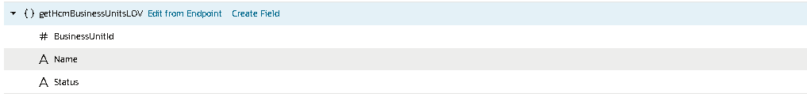
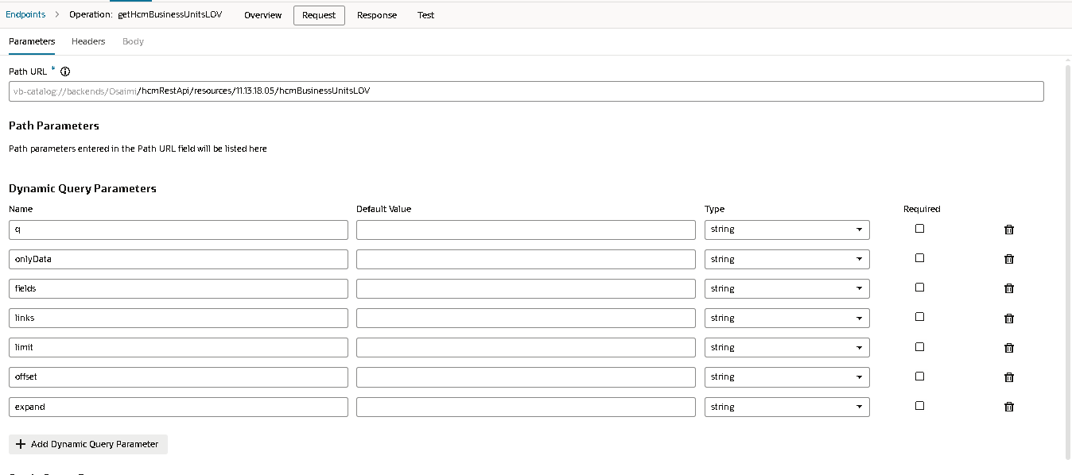
Here add the dynamic parameters as mentioned it is not required.
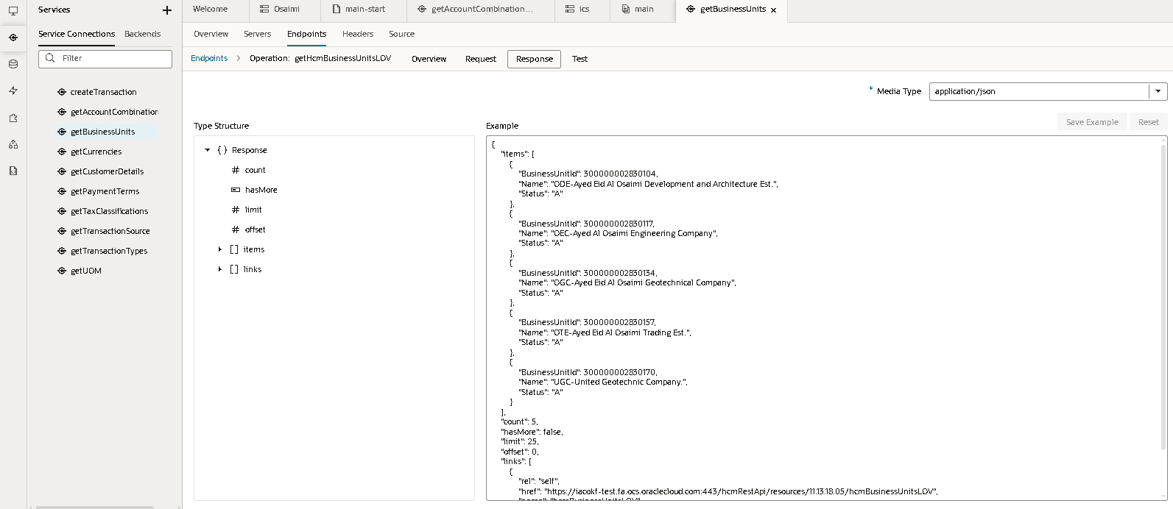
- Transaction Source
- Selected the combobox and labeled it as the Transaction source
- Calling the lov based on the [[ $variables.Var_TransactionSource ]]
- Added the action chain TransactionSourceValueChangeChain in the event.
- In the action chain assigned the value in the variable.
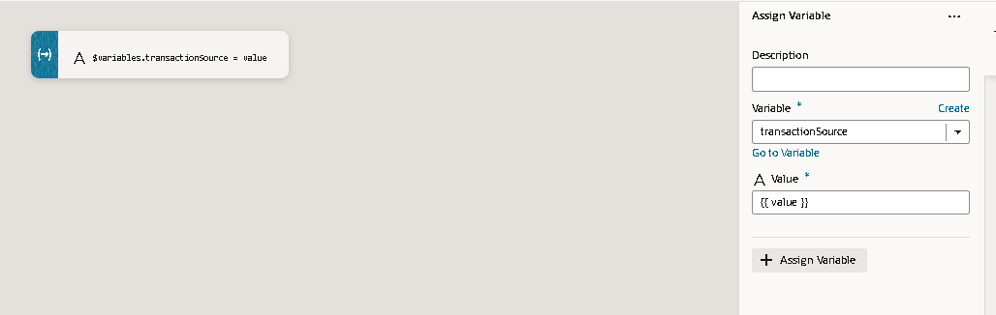
- Variable Var_TransactionSource(ADP) calling fom the item type of ‘getTransactionSourcesLOV’
- The transaction source lov the End point Structure
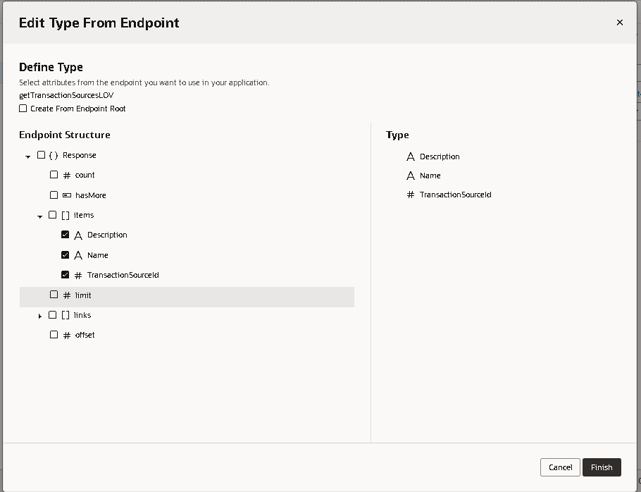

Service Connections : getTransactionSource

Calling the rest url through service connections.
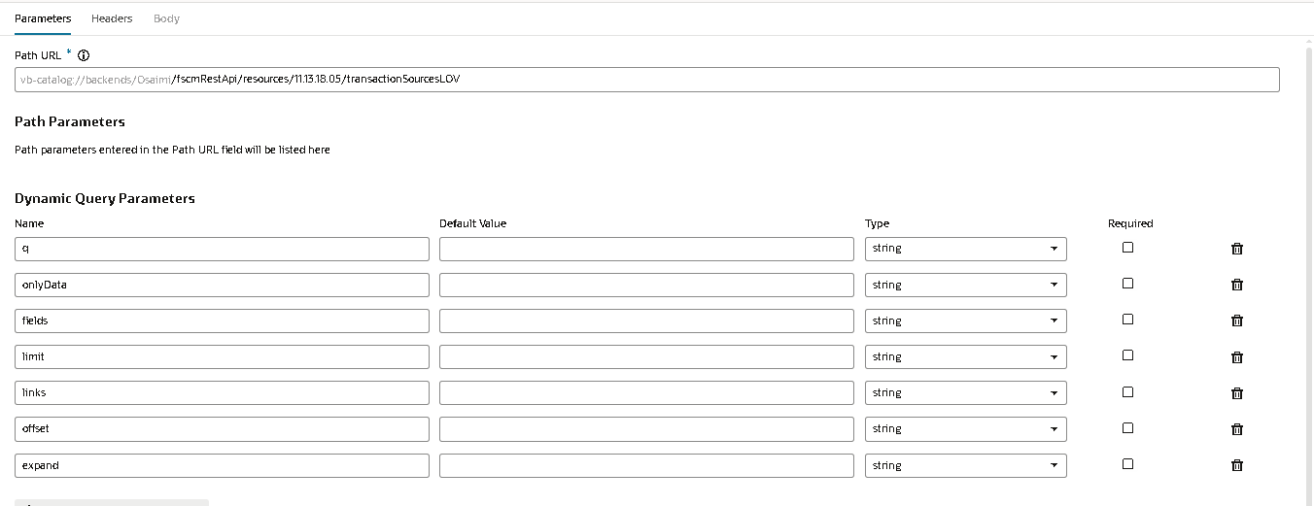
We use to get the response like this .
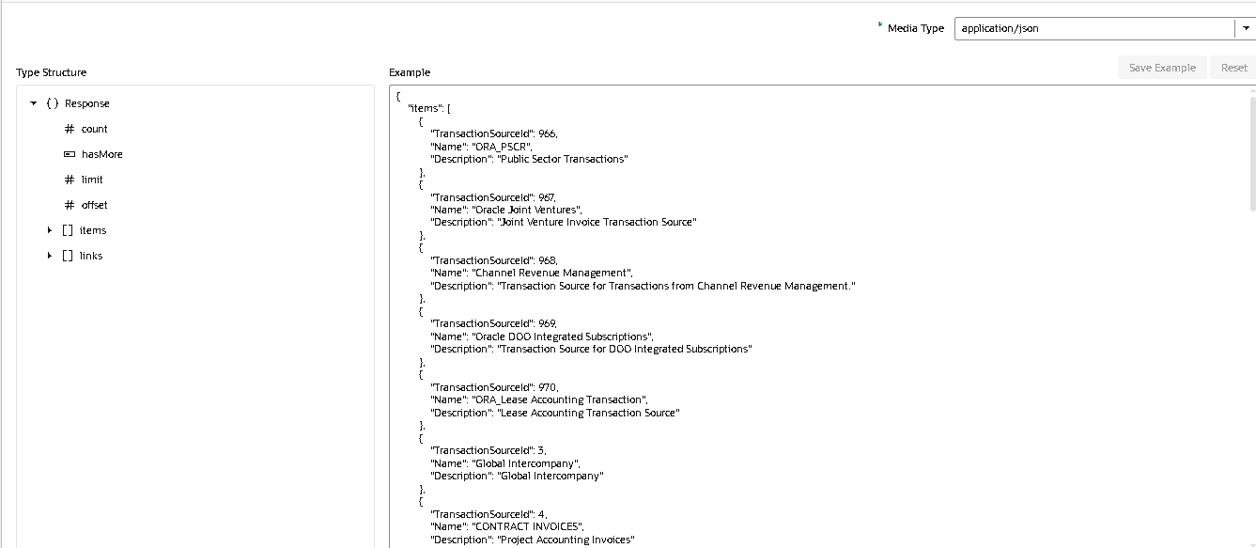

- Transaction Type:
- Selected the combo box and labelled it as a Transaction Type
- Lov data is based on the [[ $variables.Var_TransactionType ]].
- The item type of the variable is ‘getTransactionTypesLOV’

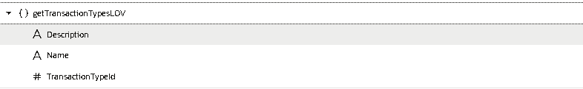
- The transaction type lov calling from the service connections.
Service connection: getTransactionTypes
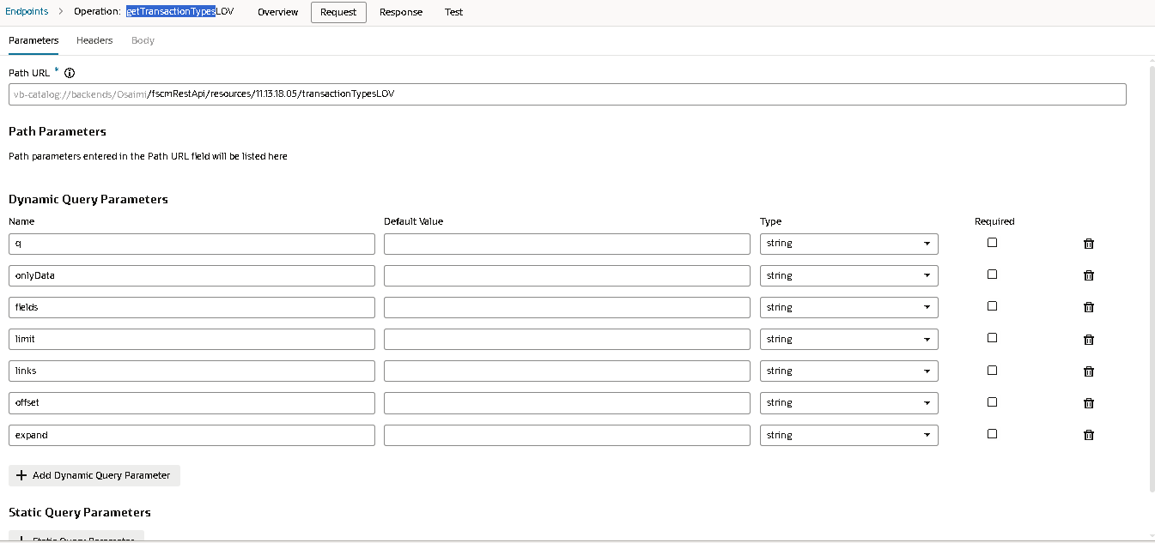
The output response will be get into the json format then the item type will be stored.
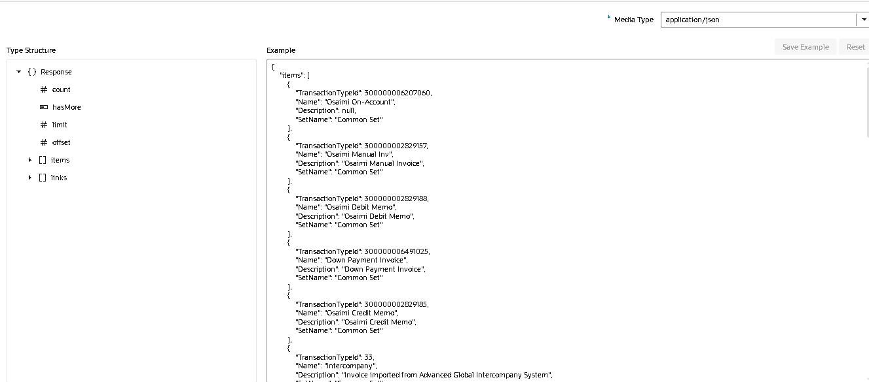
- Transaction Number:
- Drag the input text labelled it as the Transaction number.
- Enabled it for the Readonly and Required.
- We assigned the value as variable transactionNumberValue ({{ $variables.transactionNumberValue }})
- Action chain will assign the transactionNumber(Value) variable to the current value.
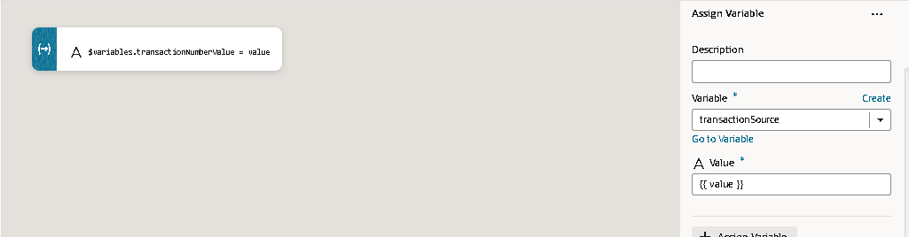
- The value transaction number will be automatically generated.
- Stored in the Transaction Number input text.
Then we will add the form layout beside the fields to store multiple data here.
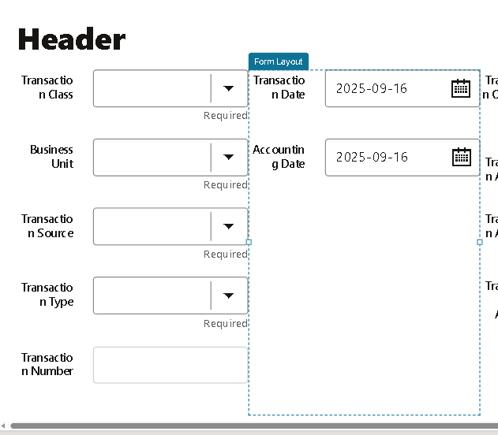
- Transaction Date
- Here we have dragged the input date field labelled as Transaction date.
- Given converter as pattern as formatted as yyyy-MM-dd.
- Given the inbuilt function given in the value ‘{{ oj.IntlConverterUtils.dateToLocalIsoDateString(new Date() ) }}’
- Creates date with current date and time.
- Added the action chain in the events.
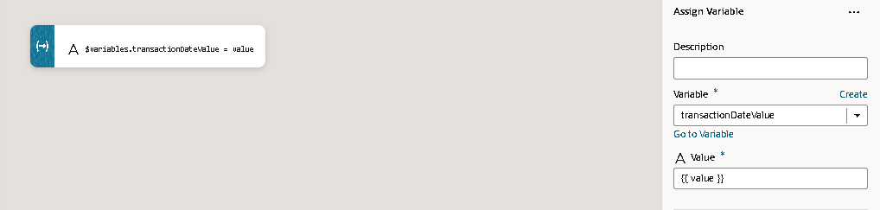
- Assigned Current value in the TransactionDateValue (Variable).

- Accounting Date
- As the same way as we created the Transaction Date the accounting date is created.
- Same inbuilt function in inserted in the value.
- In the action chain the current value is inserted into the transactionDateValue(Variable).

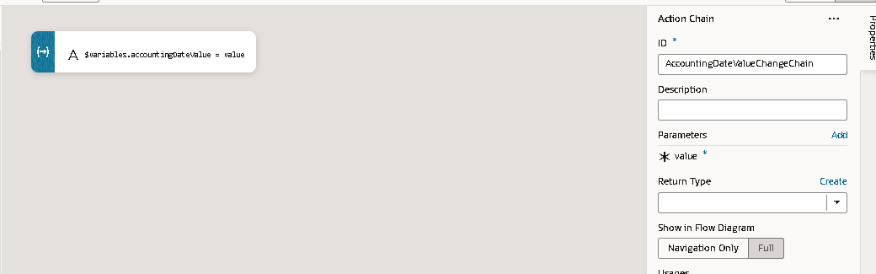
- Transaction Currency
- Dragged the combobox into the page.
- Enabled the required checkbox.
- The option is getting from the ‘[[ $variables.Var_Currencies ]]’ in which the data is coming from.
Var currencies is the adp variable calling the item type from the CurrenciesLOV.Given the key attributes as items,Text filters as items.
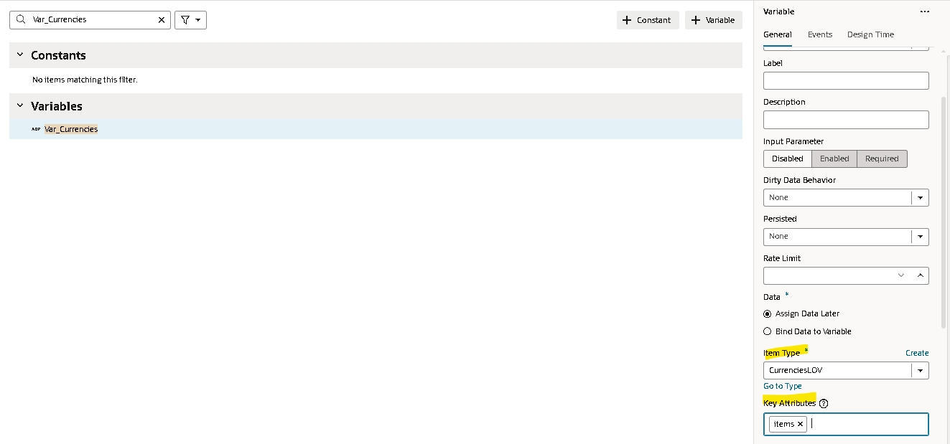
CurrenciesLOV is the item type calling it from the end point of the service connection.
Service Connection : getCurrencies
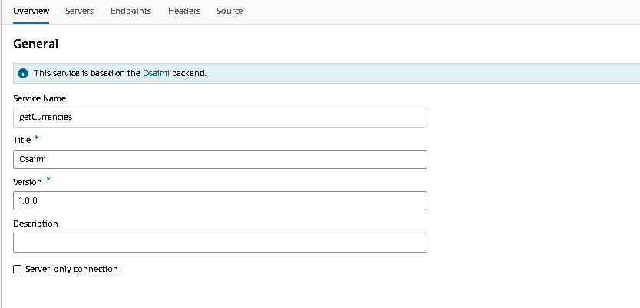
The service connection calling from the end point is getCurrencies here we have added the parameters.
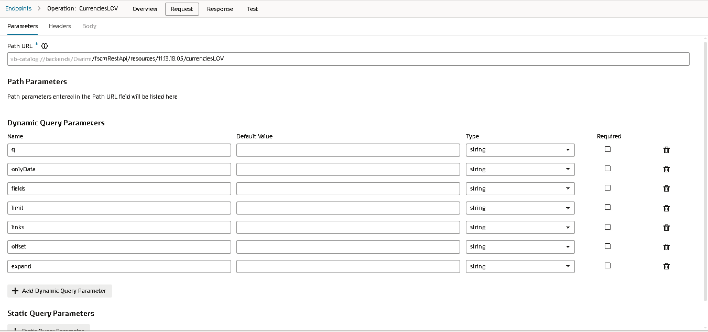
Here this will be the response where we get we only using the currency code for it.
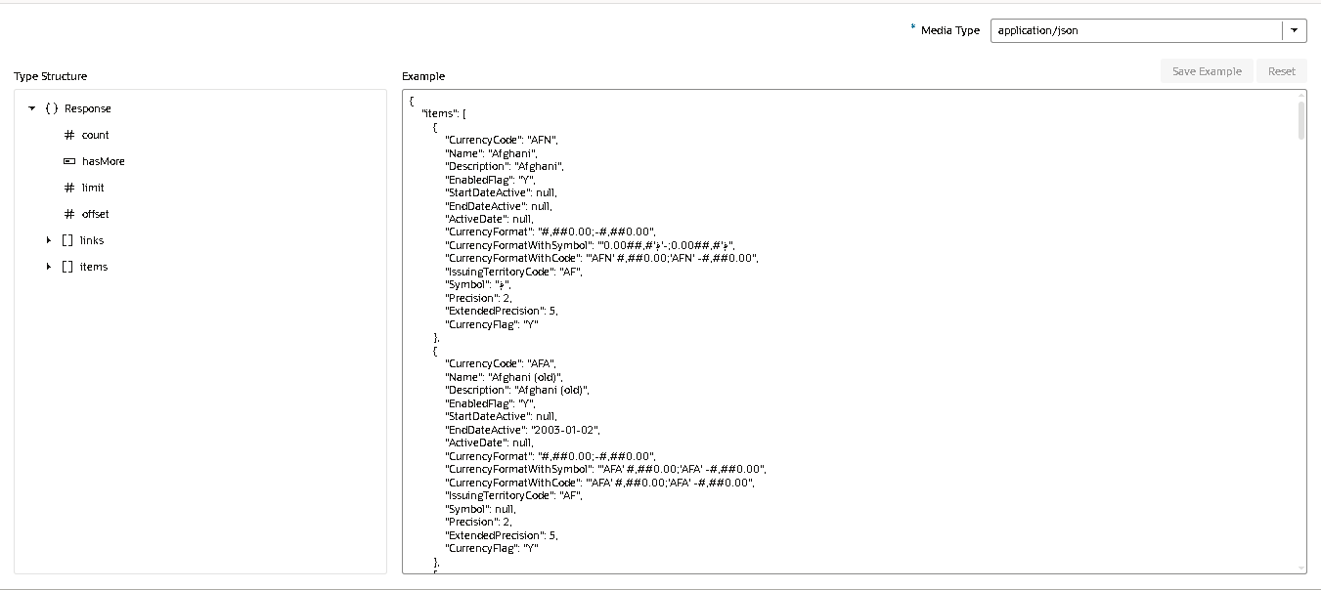

- Transaction amounts
We have 3 transaction Amounts the amounts are Total Transaction Amount,Transaction Amount and Transaction Tax Amount.
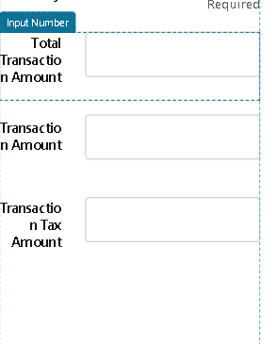
The three fields are in read-only mode, and their values are assigned from three variables {{ $variables.TotalTransactionAmountValue }} for Total Transaction Amount, {{ $variables.TransactionAmountValue }} for Transaction Amount, and {{ $variables.TaxAmountValue }} for Transaction Tax Amount.

Steps included for the development of Customer and Payment Terms.
1.Bill-To Number
Dragged the Combobox field into the page the list of values are getting from the [[ $variables.Var_CustomerDetails ]].
Given the maximum count as the -1 where we get maximum data.
The [[ $variables.Var_CustomerDetails ]] is the variable given the type as getcustomerDetails.
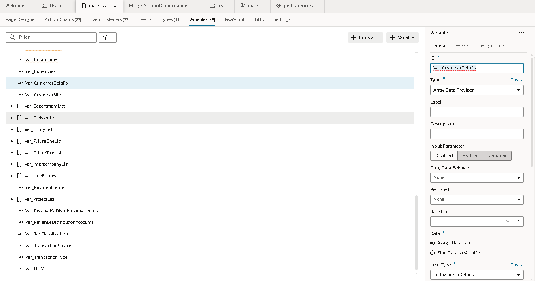
The type contains the fields like :
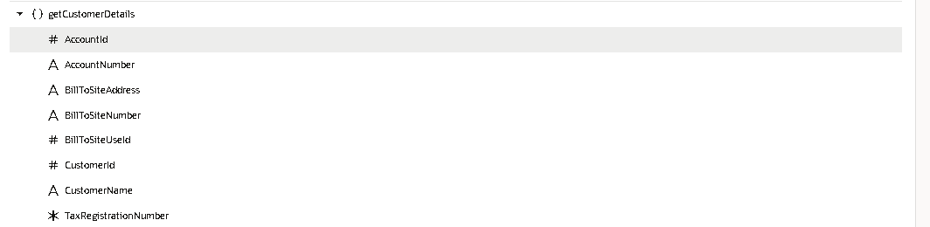
Service Connection :- getCustomerDetails
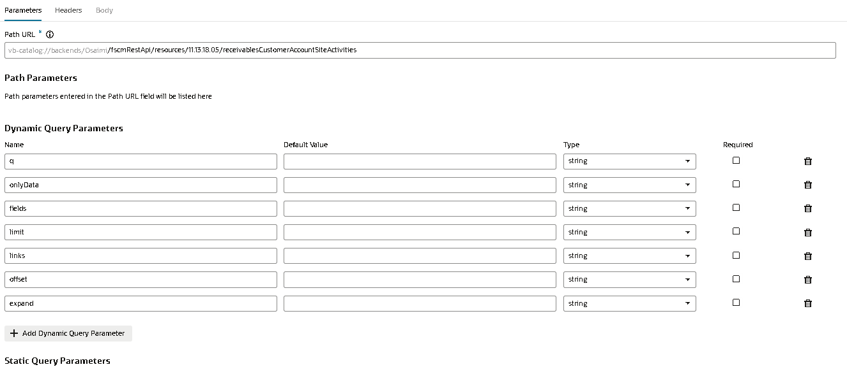
The path URL given the connection and the dynamic Parameters.
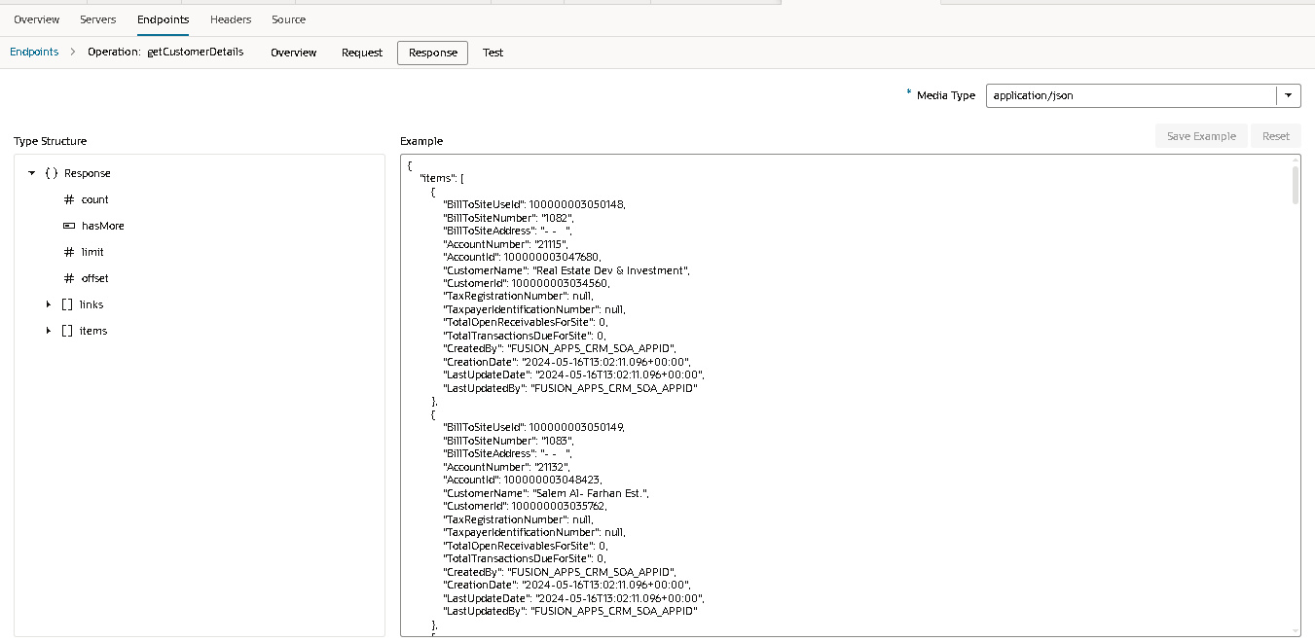
Then the response we get in this format calling this variables in lov.
The Action is called for the BillToNumberValueChangeChain in which
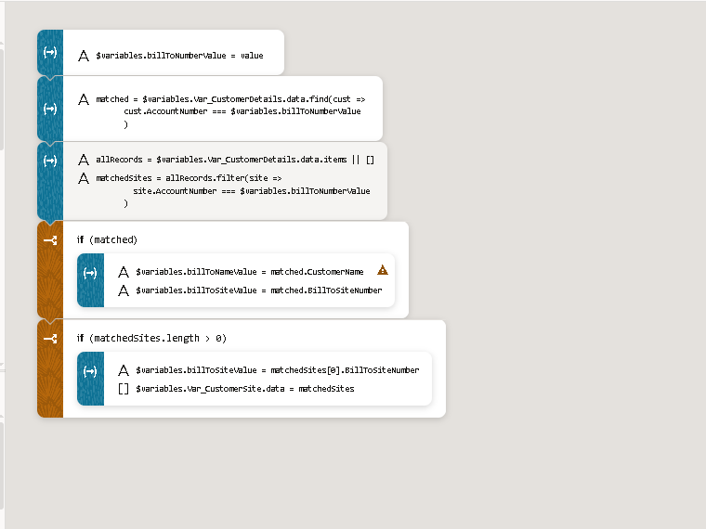
This are the steps in the action chain
- Firstly we assign billToNumberValue variable to current value.
- Then we created the one variable as ‘matched’
const matched = $variables.Var_CustomerDetails.data.find(cust =>
cust.AccountNumber === $variables.billToNumberValue
)
- $variables.Var_CustomerDetails.data → this is an array of customer details objects.
- .find will find the all account number matches with the bill to number value if it matches then store into the matched variable.
- It looks up the customer whose Account Number matches the Bill To Number and assigns that customer’s details to matched.
- Then created another variable all records and matched sites.
const allRecords = $variables.Var_CustomerDetails.data.items || [];
const matchedSites = allRecords.filter(site =>
site.AccountNumber === $variables.billToNumberValue);

- Tries to read items from $variables.Var_CustomerDetails.data.
- If items is undefined or null, it defaults to an empty array [].
- So allRecords will always be an array (safe for filtering).
- It safely gets the list of customer records and filters it to find all sites whose Account Number equals the Bill To Number in matched sites.
- If matched is not null then
if (matched) { $variables.billToNameValue = matched.CustomerName $variables.billToSiteValue = matched.BillToSiteNumber; }
- The assignment operation will be done then variables will be assigned.

- The matched sites will be length is gretar than 0 then it will occupy the given variables.
if (matchedSites.length > 0) {
$variables.billToSiteValue = matchedSites[0].BillToSiteNumber;
$variables.Var_CustomerSite.data = matchedSites;
}

2. Bill-To Name :
- IT is the input text filed labelled as the Bill to Name
- Disabled the field .
- The value is given as the {{ $variables.billToNameValue }}.
- In which the data into the variable is getting from the bill to number action chain.

3. Bill-To Site :
- The combobox value but the field is diabled in which the data is only get.
- We assigned the value as the {{ $variables.billToSiteValue }}.
- The value is assigned in the action chain of the Bill to number.
4. Payment Terms:
- In the payment terms we created the combo box the fields will be mentioned as the required field.
- The data is getting from the given options.
- The variables are the key attributes and the item type.
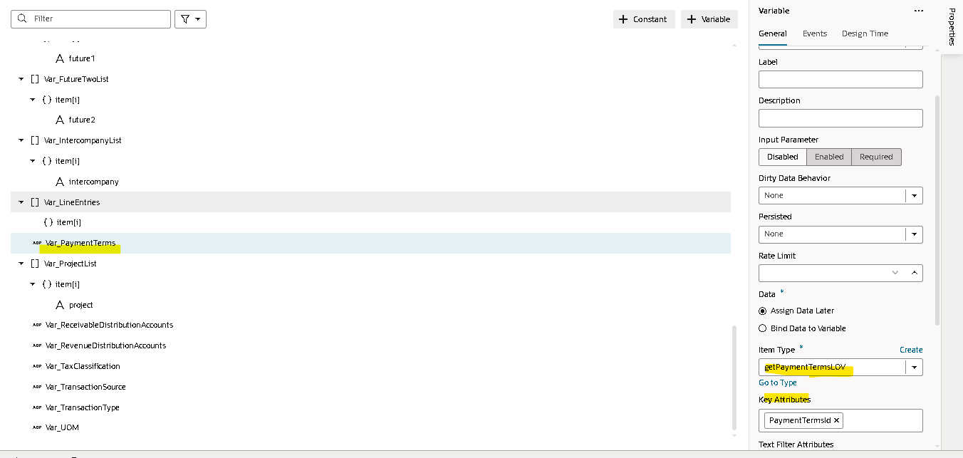
- The item type for the this variable
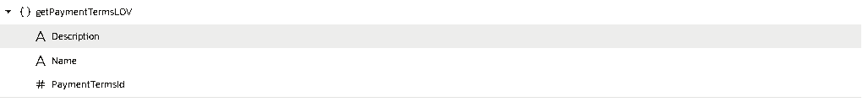
Service connection: getPaymentTerms.
The url and the dynamic parameters are added in the request payload.
The response will caught in the responsed.

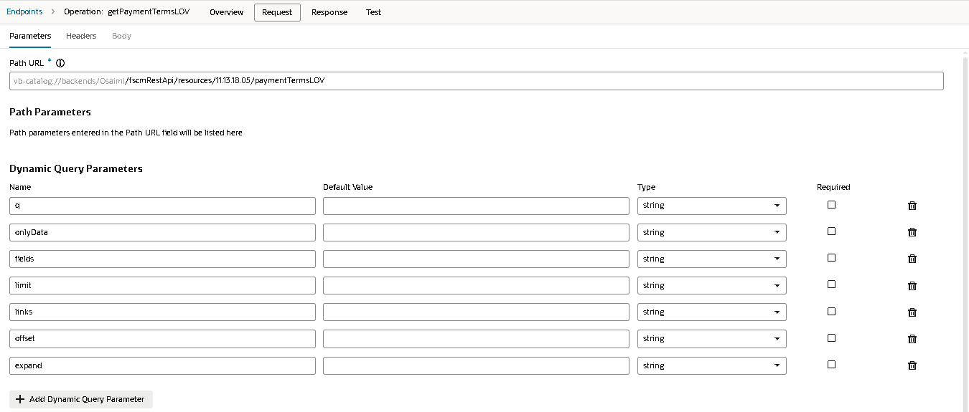
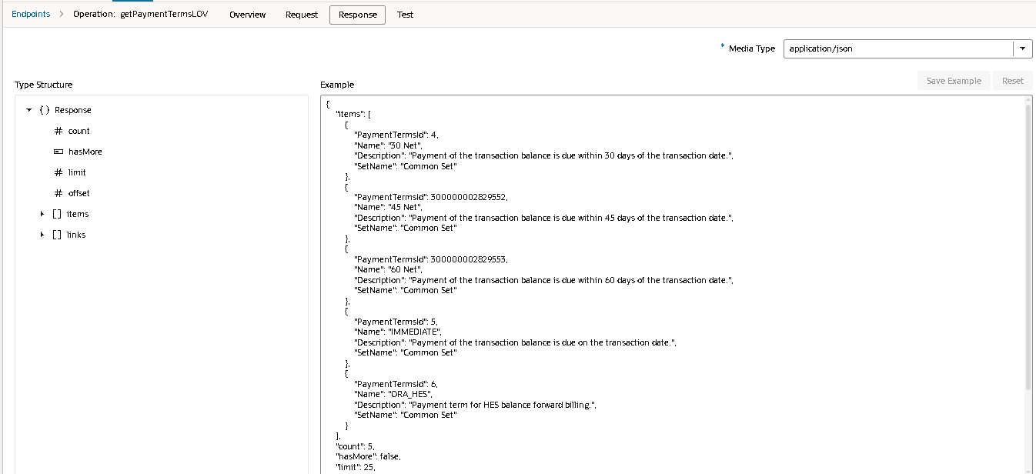
The action chain is called on value change in event.
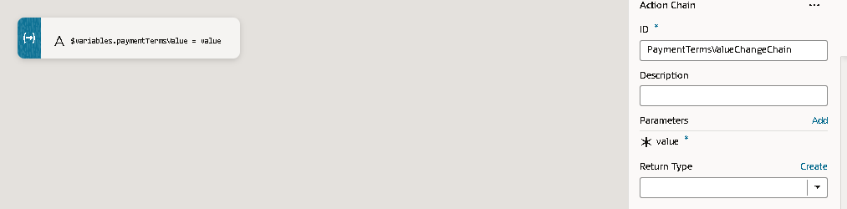
The current value is stored in the paymentTermsValue.
For the customer and the payment terms we have used the form layout to separate the sections.

Steps involved for the development of the distributions fields:
- Receivable Distribution:
- Selected the input box and dragged into the page labelled it as ‘Receivable Distribution’.
- Enabled it as the required field.
- Given the value as {{ $variables.Var_ConcatenatedSegments }} variable of string
- Selected the ICON where selected as Caret Down
- Need to automatic get the data.
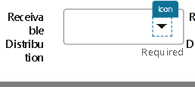
- In the Icon we open the dialog box get the some columns.
- Click on the Action chain (selectDistributionButtonActionChain).
- In the Action chain call component.
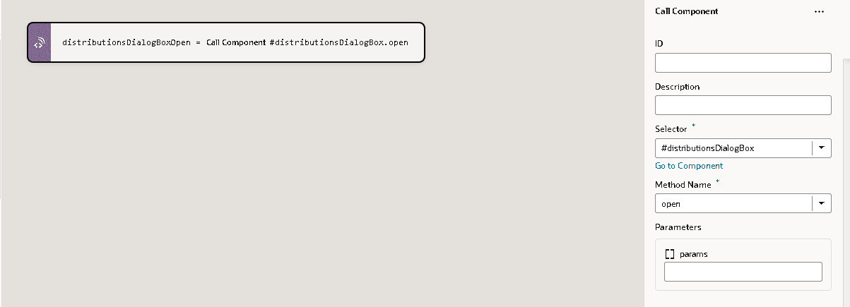
- In the dialog box the combox fields are added.
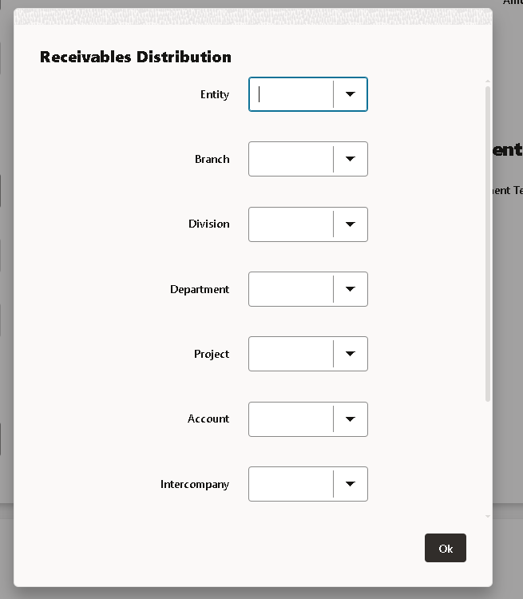
- In the combobox fields the options are added .
- Entity,Branch,Division,Department,Project,Account,Intercompany,Future1 and Future2. This includes the Code combination.
- Here we have the options to the data.Need to add the action for it.To get the values in it.

- The ‘Ok’ button is cliked then the dialog box will be closed the action chain is used to close .

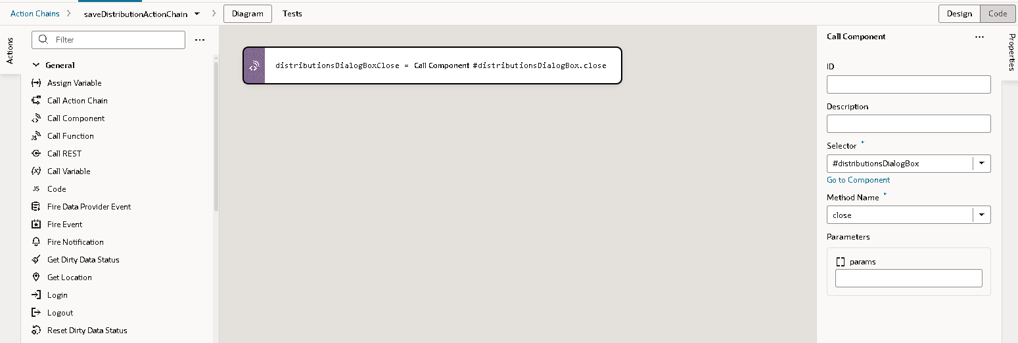

- Revenue Distribution:
- Given the input text and labelled it as the Revenue Distribution.
- The data will need to auto populate in the field.

Steps involved to develop the lines field:
In the heading we have as title as the Lines.
- Then we have added the labels to given the text value as the line fields.
- Example the fields are (Line Number,Description,UOM,Quantity,Unit price,Amount and Tax classification.
- Click on the enable the Show Required fields.
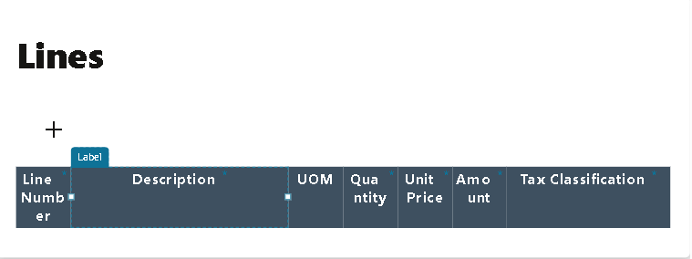
For the ‘+’ icon here we called the button to dragged in the page.
- Selected icon as the ‘plus’ icon and styling as Small.Made chroming as Borderless.
- We called the action chain in the events.
- The action chain is oj-action (AddActionChain).
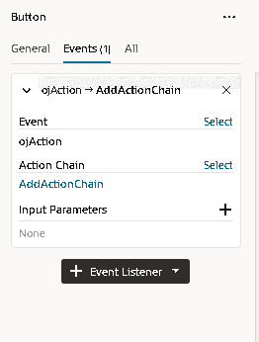 | 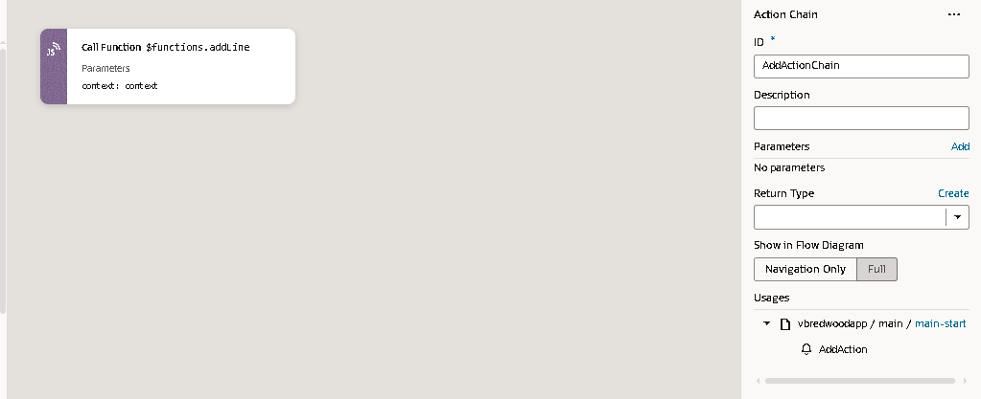
- In the action we have called the java script where in that script the new line will be added.
- The Javascript used as shown below.
addLine(context) {
const lines = context.$page.variables.Var_LineEntries;
const newRow = {
lineNumber: lines.length + 1, // auto-increment
lineDescription: "",
uom: "",
quantity: null,
unitSellingPrice: null,
lineExtensionAmount: null,
taxClassificationCode: ""
};

lines.push(newRow); // push into array
}
- This java script is calling in the action by call Function.
- By clicking on the ‘+’ icon the newRow will be created as shown in the Fields.
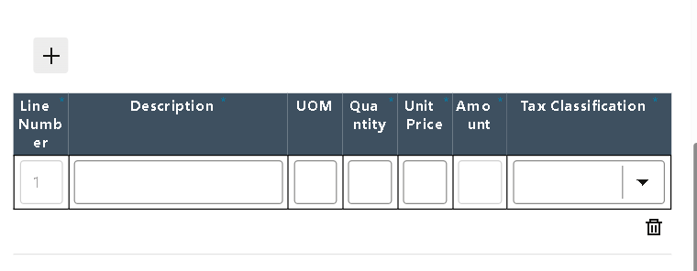
- Here there is another Icon like delete we have created the action chain for it when the user click on the icon the rows will be deleted.
- On Oj-action Event Created the Delete action.
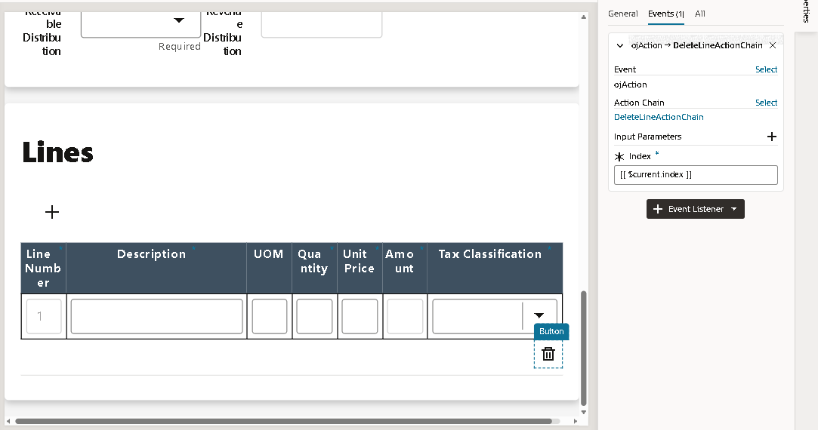
- Calling the function as delete line in the action chain.
deleteLine(context, index) {
let lines = context.$page.variables.Var_LineEntries;

if (Array.isArray(lines) && index >= 0 && index < lines.length) {
lines.splice(index, 1);
// Reassign to force UI update
context.$page.variables.Var_LineEntries = [...lines];

// Optional renumber
context.$page.variables.Var_LineEntries.forEach((line, i) => {
line.lineNumber = i + 1;
});
}
}

- The parameters like the Context and index are passed into the function.
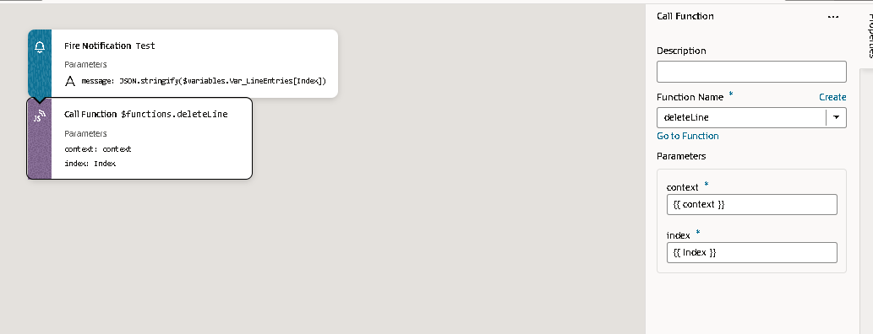
- The index will be the current index.

Fields in the lines assigned.

- The fields used in the label assigned the Input values are given in the label text and label ID.
- Then we have add the description,Uom,quantity,Unit price, Amount, Tax Classification.
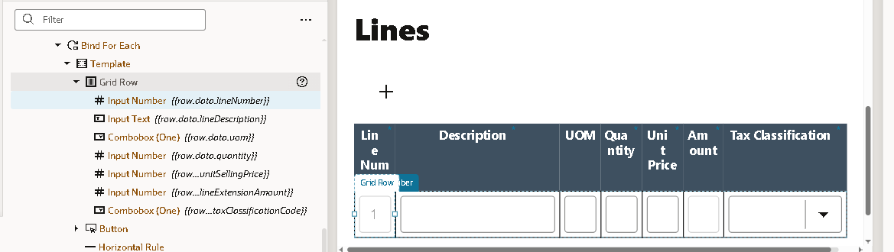
- For the tax classification code we need to add the combobox for it.to get the list of value.
- The value is getting from the [[ $variables.Var_TaxClassification ]] variables.
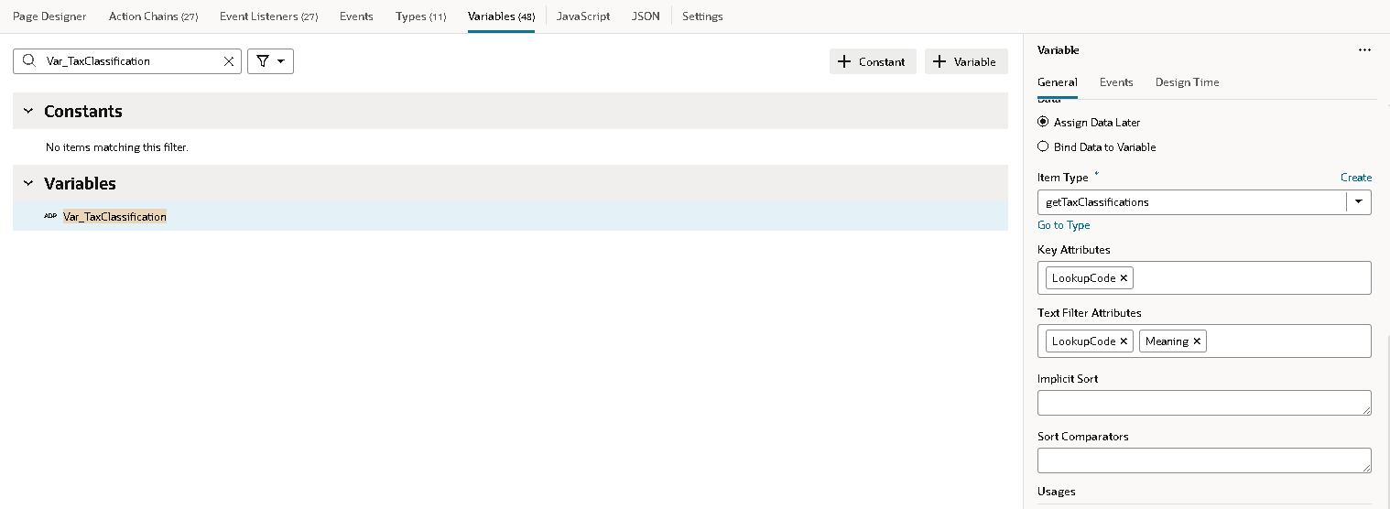
- Item type has given for these type getTaxClassifications (Item Type).
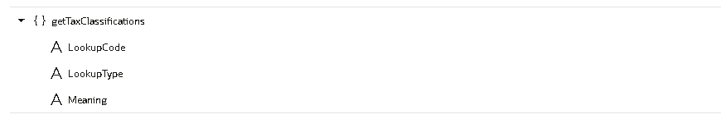
- The fields used in this Type getTaxClassifications service connections.
- Value is given in the {{row.data.taxClassificationCode}}.
- The Action chain is added in the Event.
- Calling the Java Script Function in the Action.
calculateTransactionAmounts(context, indx) {
const lines =context.$page.variables.Var_LineEntries[indx];
const taxClassificationCode = lines.taxClassificationCode;
const qty = parseFloat(lines.quantity) || 0;
const price = parseFloat(lines.unitSellingPrice) || 0;
const lineExtensionAmount = qty * price;

let totalAmount = context.$page.variables.TotalTransactionAmountValue || 0;
let transactionAmount = context.$page.variables.TransactionAmountValue || 0;
let taxAmount = context.$page.variables.TaxAmountValue || 0;
let taxRate = 0;

if (taxClassificationCode?.includes('VAT15')) {
taxRate = 0.15;
} else if (taxClassificationCode?.includes('VAT5')) {
taxRate = 0.05;
}

if (typeof taxAmount === 'undefined' || taxAmount === null) {
taxAmount = 0;
}

transactionAmount += lineExtensionAmount;
taxAmount += (lineExtensionAmount * taxRate);
totalAmount = transactionAmount + taxAmount;

context.$page.variables.TotalTransactionAmountValue = totalAmount;
context.$page.variables.TransactionAmountValue = transactionAmount;
context.$page.variables.TaxAmountValue = taxAmount;
}

- This function takes one line of a transaction (quantity × price), applies VAT if applicable, and updates the running totals (transactionAmount, taxAmount, totalAmount) on the page.
const qty = parseFloat(lines.quantity) || 0;
const price = parseFloat(lines.unitSellingPrice) || 0;
const lineExtensionAmount = qty * price;

- The qty and the price are given by the user but the amount field the lineExtensionAmount is calculated in by the above Js and assigned in the amount label.
- In the above js function
transactionAmount += lineExtensionAmount;
taxAmount += (lineExtensionAmount * taxRate);
totalAmount = transactionAmount + taxAmount;

context.$page.variables.TotalTransactionAmountValue = totalAmount;
context.$page.variables.TransactionAmountValue = transactionAmount;
context.$page.variables.TaxAmountValue = taxAmount;
- After selected the tax classification code the value will be assigned in the Header fields like TotalTransactionAmountValue, TransactionAmountValue and TaxAmountValue.

Calling the post method to create the customer.
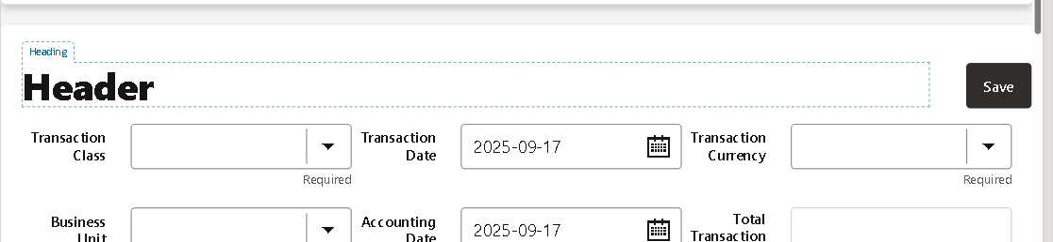
- After filling the data in the all the fields clicking on the save.
- The post method is called in the Save button Action chain.
- On oj-action the create transaction Action is called in the event.
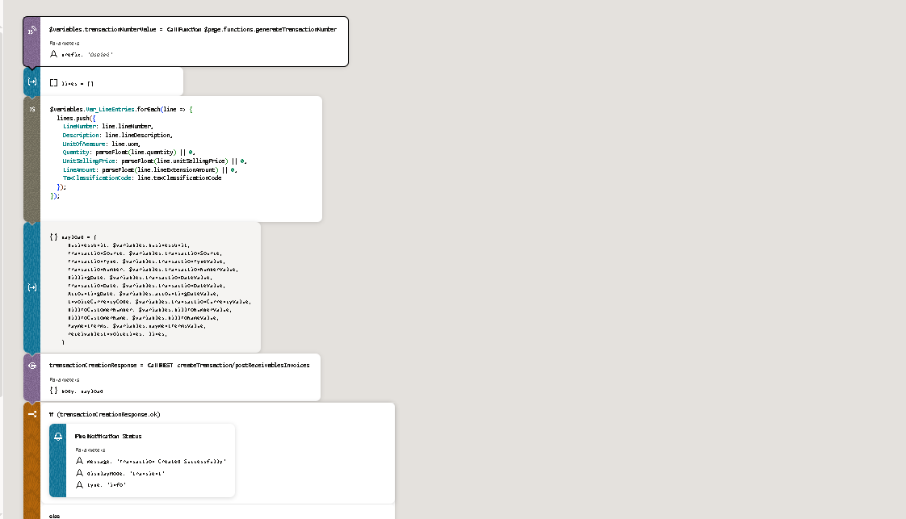
- Firstly we are calling the Js function getTransactionNumber.
generateTransactionNumber(prefix = "Osaimi") {
const now = new Date(); // Format date as YYYYMMDD
const datePart = now.toISOString().slice(0,10).replace(/-/g, '');

// Add a random 4-digit number for uniqueness
const randomPart = Math.floor(1000 + Math.random() * 9000);

// Combine all parts
return `${prefix}${datePart}${randomPart}`;
}

it generates a unique transaction number string using a prefix, today’s date, and a random number.
- Lines array is defined type array is declared.
$variables.Var_LineEntries.forEach(line => {
lines.push({
LineNumber: line.lineNumber,
Description: line.lineDescription,
UnitOfMeasure: line.uom,
Quantity: parseFloat(line.quantity) || 0,
UnitSellingPrice: parseFloat(line.unitSellingPrice) || 0,
LineAmount: parseFloat(line.lineExtensionAmount) || 0,
TaxClassificationCode: line.taxClassificationCode
});
});
It loops through all the records in Var_LineEntries (probably a VBCS page variable holding line items), and for each one, it builds a new object with clean/normalized values, then adds it into the lines array.
- Then Calling the Payload created variable as the payload and type as object.
BusinessUnit: $variables.businessUnit,
TransactionSource: $variables.transactionSource,
TransactionType: $variables.transactionTypeValue,
TransactionNumber: $variables.transactionNumberValue,
BillingDate: $variables.transactionDateValue,
TransactionDate: $variables.transactionDateValue,
AccountingDate: $variables.accountingDateValue,
InvoiceCurrencyCode: $variables.transactionCurrencyValue,
BillToCustomerNumber: $variables.billToNumberValue,
BillToCustomerName: $variables.billToNameValue,
PaymentTerms: $variables.paymentTermsValue,
receivablesInvoiceLines: lines,
}

- Calling the Rest connection in that payload is upload .
- Store Result in the ‘transactionCreationResponse’.
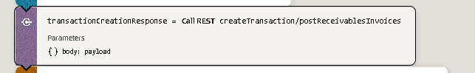

Then we will call the Rest connection in the Response.

Calling the notification in the page like it created or not created.
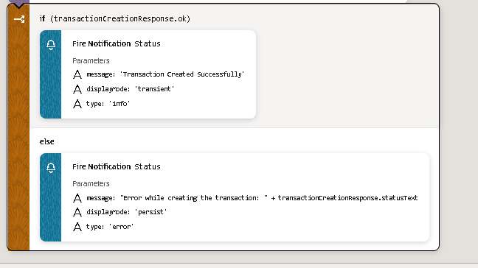

The Overview of the Page.
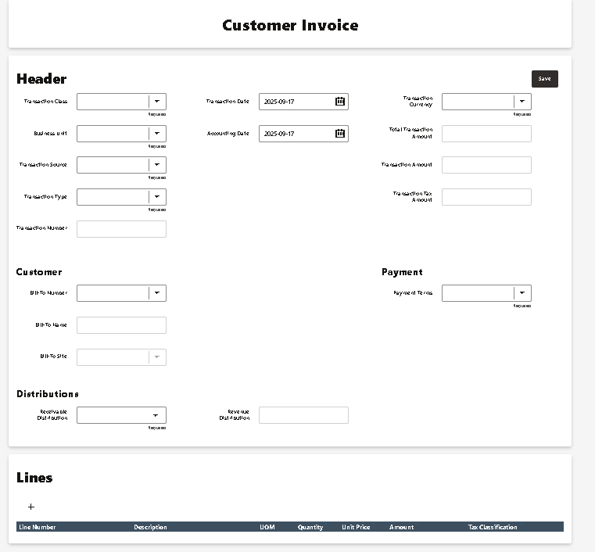
HTML
Java script
VBCS File

